Matura paper

**turn that down!**

The Creation of a Synthesizer

Nikolaj Veljković, G25f

Supervised by Sacha Di Piazza



Gymnasium Kirchenfeld

Bern 2024

Table of Contents

1 Introduction 3

2 Theory 4

2.1 Terminology 4

2.2 Components 4

2.2.1 Static and variable resistors 4

2.2.2 Capacitors 5

2.2.3 Inverting Schmitt trigger 6

2.2.4 NAND logic gate 7

2.2.5 Operational amplifier and buffer 7

2.3 Building blocks 8

2.3.1 VCO 8

2.3.2 VCF 9

2.3.3 VCA 10

2.3.4 Envelope generator 10

2.3.5 LFO 11

2.4 Typical synth architecture 12

3 Process documentation 13

3.1 Tools 13

3.2 Prototyping 13

3.3 Soldering 18

3.4 Building the case and assembly 20

4 Critical analysis and improvements 24

5 Acknowledgments 26

6 Appendix 27

6.1 Additional Images 27

6.2 References 33

7 Statutory declaration 38

# Introduction

I was inspired to write the following paper on the topic of analogue synthesizers due to my fascination for technology and music. While searching for a topic I knew that I needed something that would make me engage and where I could put my energy into. Seeking a challenge, building a synthesizer seemed to be just right – combining my interests and allowing me to discover a domain of technology I had not been familiar with before. It allowed me to learn about principles of analogue electronics and synthesizer design. In this paper I first explained what the main components of a synthesizer are, as well as the hidden processes behind the creation of the sound. Then, I described how I planned and built a synthesizer myself. My goal was to deeply understand the inner workings of synthesizers while building my own. In my opinion, it is important that one understands the fundamentals of analogue electronics, as these topics get lost with the digitalisation of our world. To achieve this, I first taught myself the electronic workings of a synthesizer, then built prototypes until I reached a desired outcome. As soon as I held a working prototype in my hands, the next step was soldering it onto a protoboard, making it compact. The last step was putting the raw synthesizer into a nice case. My final goal was to hold a synthesizer in my hands that I had built and designed myself.

# Theory

To explain how a synthesizer functions, it is important to understand what individual components it consists of and how these components work together. I will use a water analogy to describe the influence of individual parts, as on a high level electrical current functions much like the flow of water. Further, I will use 12V as reference voltage while explaining certain mechanisms, but in every example the voltage could also be smaller or higher.

## Terminology

* Power supply: This is the source of the electricity flowing through the circuit.
* Ground (GND): Name for the point where electricity flows out. In a circuit with a battery as the power supply the negative terminal is the ground [1].
* Voltage (V): For simplicity’s sake, voltage can be imagined as the amount of pressure in a water pipe. It gives us an understanding of how hard the electrons are being pushed through a circuit. Less voltage means also less water at a time being pushed through the pipe [2].

## Components

### Static and variable resistors

Current flowing through a circuit is similar to water flowing through a pipe. In electronics, the wire is the pipe. When the water has no obstacle, it flows freely. Once a resistance, in the case of Figure 2.1 the sand, is introduced, the amount of the water flowing through the pipe is decreased [3].

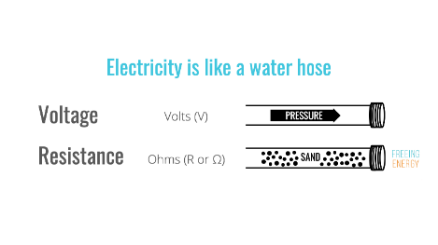

Figure 2.1: The water analogy in a picture. Bill Nussey, Freeing Energy: <https://www.freeingenergy.com/understanding-the-basics-of-electricity-by-thinking-of-it-as-water/> [accessed and edited by Nikolaj Veljkovic 11 10 2024]

Figure 2.2 shows a static resistor and its symbol in a circuit diagram. It usually has four to five coloured bands, which allow to identify the resistance of an individual resistor. These colour-codes can be read by using a resistor colour chart [Appendix 6.1]. As opposed to other components, a resistor is apolar. This means it has no “right” direction. Inside the resistor there is a material that inhibits conductivity [4]. This material prevents the full current from passing through the resistor, decreasing the current in the circuit [3]. It is like the sand in the pipe.

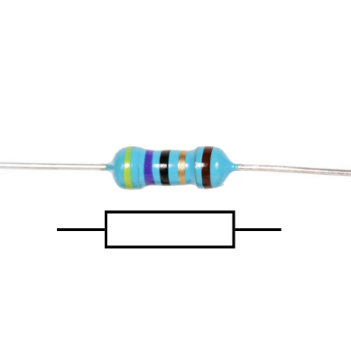

Figure 2.2 : A five-band resistor and its circuit diagram symbol. randofo, Instructables: <https://www.instructables.com/Resistors/> [accessed and edited by Nikolaj Veljkovic 29 09 2024]

A variable resistor has a different layout. It has three pins, a coil of resistive material and knob attached to a wiper, which is connected to the middle pin. By connecting an input voltage wire to an outer pin, and an output wire to the middle one, this will act as if a static resistor was between the two wires. Only that the value of the resistor can be dynamically changed by turning the knob. As one can see in Figure 2.3, the longer the connection of the input pin to the wiper head is, the more resistive coil is between the two. This leads to greater resistance. In a perfect variable resistor, the knob turned to the maximum corresponds to the maximal resistance. Vice versa, the knob to the minimum should yield no resistance. The maximal resistance is written on the top of the potentiometer [5].

A resistance is measured in Ohm Ω [6]. When the values become big, they are written as kΩ (kiloohm – one thousand ohms) or even MΩ (megaohm – one million ohms).

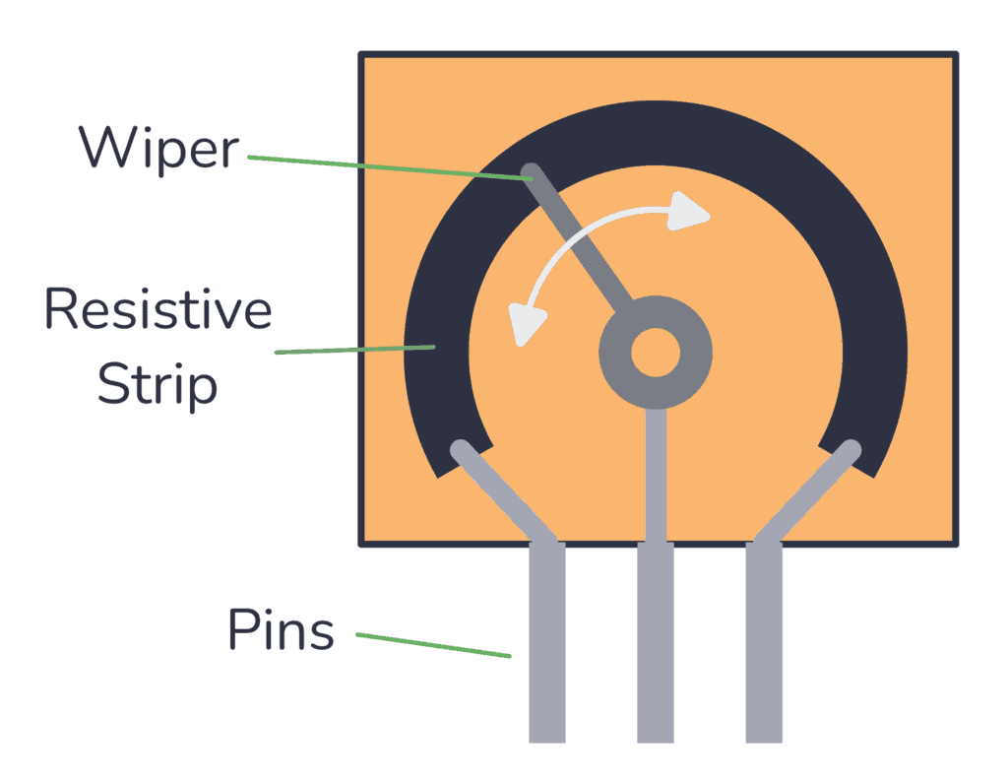

Figure 2.3 : The inside of a variable resistor. Øyvind Nydal Dahl, buildelectroniccircuits: [https://www.build-electronic-circuits.com/variable resistor/](https://www.build-electronic-circuits.com/potentiometer/) [accessed 29 09 2024]

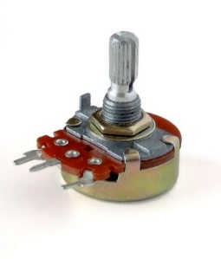

Figure 2.4 : A variable resistor. Iainf, Wikipedia Commons: [https://commons.wikimedia.org/wiki/File:Variable resistor.jpg](https://commons.wikimedia.org/wiki/File:Potentiometer.jpg) [accessed 29 09 2024]

### Capacitors

The capacitor in its function is similar to a water balloon [Figure 2.5]. When one attaches the water balloon to a pipe, it fills up with water until its pressure is equal to the pressure in the pipe. At some point, when the pressure drops in the pipe, the balloon starts pushing the water back into it [7, 8].

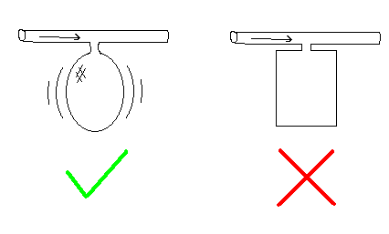

Figure 2.5: A balloon attached to a water pipe. mackys, Livejournal: <https://mackys.livejournal.com/914252.html> [accessed and edited by Nikolaj Veljkovic 11 10 2024]

In an electronic circuit, the capacitor stores charge on one of two plates. As the electrons build up on one plate, the other plate has fewer electrons, because it discharged its electrons into the power supply. This creates a potential difference between the two plates, equal to the voltage of the power supply [9].

Figure 2.6 shows multiple capacitors. A capacitor’s charging capacity, or capacitance, is measured in Farads [10]. In practice, this unit is much too big. Usually capacitors range from Microfarad (mF = 10-6 F) to Picofarad (mF = 10-12 F). In Figure 2.6 one can see the capacitance denoted very clearly on the polarised capacitor (10mF). On the smaller, nonpolarised ones, the values are abbreviated with numbers and letters [11].

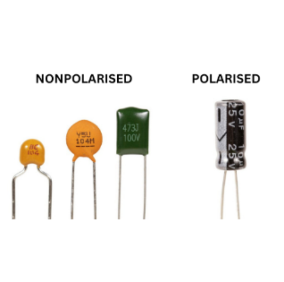

Figure 2.6 : Different capacitors. unknown, Jak Electronics: <https://www.jakelectronics.com/blog/what-is-non-polarized-capacitor> [accessed and edited by Nikolaj Veljkovic 29 09 2024]

### Inverting Schmitt trigger

The following components are not single discrete components, but a combination of different discrete components. They are called integrated circuits (ICs) [12]. It is not in the scope of this matura paper to explain how integrated circuits work on a deeper level, as their function is much more important. Also, the following ICs only detect the voltage at the input and process that information. The current does not go directly through the circuit. There is an input for a supply voltage and ground connection. This is where the IC draws energy from, enabling it to output according to the calculated output signal [13, p. 8.1].

A Schmitt trigger is a type of comparator, which means that it reads the analogue value at its input and compares it to its internal thresholds [14]. The exact thresholds differ from IC to IC and supply voltage, but it is easiest to imagine these as equidistant from the exact middle. The middle is the value between the maximal and minimal value. One threshold is below and one above the middle value. If the value at the input is below the lower threshold and rising, the output reads low. Once the input value surpasses the upper threshold, the output turns high. On the other hand, when the value is high and falling, the output will only switch to low once the lower threshold has been passed. When the value stays between the two thresholds, the output voltage does not change, which is what makes it prone to noisy inputs. This is called hysteresis [14, 15].

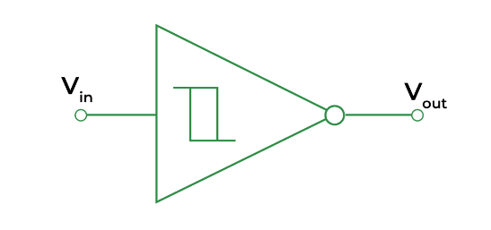

Figure 2.7 : Inverting Schmitt trigger. unknown, GeeksForGeeks: <https://www.geeksforgeeks.org/schmitt-trigger/> [accessed 29 09 2024]

At the same time, the Schmitt trigger is also an analogue to digital converter [14]. A digital signal is defined to be 1 or 0 (equivalent to high or low, on or off), whereas an analogue signal uses a continuous range of values [16]. The signal at the input is analogue, ranging from 0V to 12V, the output is digital, 12V (high) or 0V (low).

The inverting Schmitt trigger does the same a Schmitt trigger does, only that it outputs the inverse of what a Schmitt trigger would. When the input is over the threshold and the Schmitt trigger would output high, the inverting Schmitt trigger outputs low. And the other way around [14].

### NAND logic gate

Logic gates are circuits which take one or more binary inputs (1 or 0, high or low) and generate a single binary output based on the logical operation they represent [17]. NAND stands short for NOT AND, which is a combination of two gates. In an AND gate, the output is high when all inputs are high [18]. The NOT gate inverts that logic [19]. In the truth table [Figure 2.8] one can see what this means: The NAND gate always outputs high, except if both inputs are high [20].

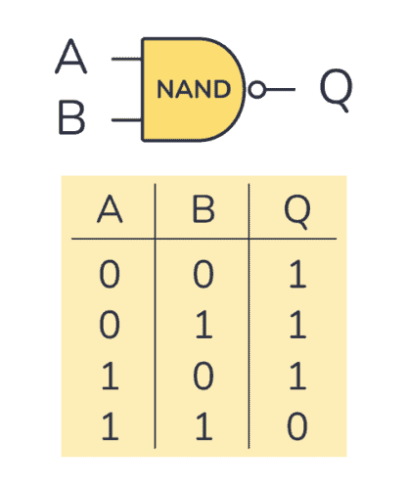

Figure 2.8 : NAND gate and its truth table. Øyvind Nydal Dahl, buildelectroniccircuits: <https://www.build-electronic-circuits.com/nand-gate/> [accessed [29 09 2024]

### Operational amplifier and buffer

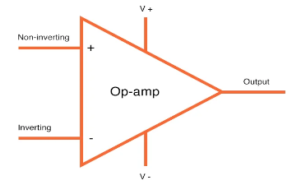

Figure 2.9 : op amp. unknown, All About Circuits: [https://www.allaboutcircuits.com/uploads/articles/op amp-in-schematics.jpg](https://www.allaboutcircuits.com/uploads/articles/op-amp-in-schematics.jpg) [accessed 29 09 2024]

An operational amplifier (op amp) is an integrated circuit with a differential input, which means that it calculates the difference between its two inputs. One input is called an “inverting input” and is indicated with a minus sign. The second input is a “non-inverting input” and is indicated with a plus sign. As in every IC, it also has two power connections, the positive and negative voltage connections [21, 22].

The op amp amplifies the difference of its two inputs. It takes the voltage at the non-inverting input, e.g. 8V, and subtracts it by the voltage on the inverting input, e.g. 3V. The result gets amplified by a specific amplification factor called A, e.g. 100’000. The output will therefore be $5V*{100}^{'}000={500}^{'}000V$. As this is impossible, the op amp outputs the maximum supply voltage, 12V [23].

In a buffer [Figure 2.10], there is a signal coming into the non-inverting input, for example 9V. The inverting input is connected to the buffers output. In the beginning, the output is zero, therefore, the inverting input is also zero. The subtraction equals 9V, so the op amp will try to output 9V. As it does so, after a fraction of a second the output will be at e.g. 3V. This makes the difference smaller, but the gain with which it gets amplified is still large enough that the output rises. The calculation will keep happening until the difference of the two inputs is extremely small. The output will then be approximately the same value as the non-inverting input. This is called a negative feedback loop [23]. Buffers are used to stabilise a signal [24].

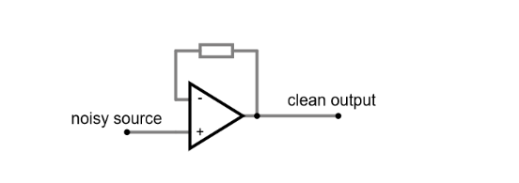

Figure 2.10 : An op amp buffer. Nikolaj Veljkovic, Falstad: <https://tinyurl.com/23cypsgv> [created 29 09 2024]

## Building blocks

### VCO

The voltage-controlled oscillator (VCO) is the sound source of an analogue synthesizer. The sound’s characteristics are defined by its waveshape. The pitch of the produced sound depends on how many cycles there are per second, where more cycles per second (Hz) result in higher frequencies [25]. A cycle is complete when an entire wave has passed and starts repeating again [26]. The shape of the wave defines the timbre of the sound [27].

The most common waveshapes in synthesizers are: Square, Triangle, Sine, and Sawtooth, as seen in Figure 2.12 [28]. Different waveshapes produce different sounds, which stem from the amount of overtones. A sine wave has no overtones, it is a pure fundamental tone. The sawtooth and square waves have low and high amounts of odd overtones respectively. Triangle waves have all overtones, but they decrease in their amplitude (loudness) depending on the ratio of the overtone to the fundamental. While a pure sine wave cannot be found in nature, the square wave has a typical grit and harshness [28, 29].

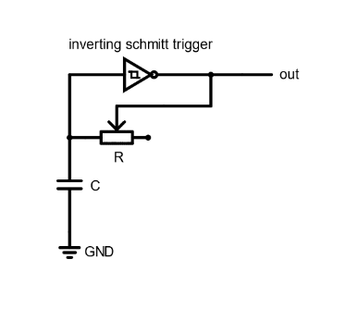

Figure 2.11 : A simple square wave oscillator. Nikolaj Veljkovic, falstad.com: <https://tinyurl.com/29x8r54f> [created 18 08 2024]

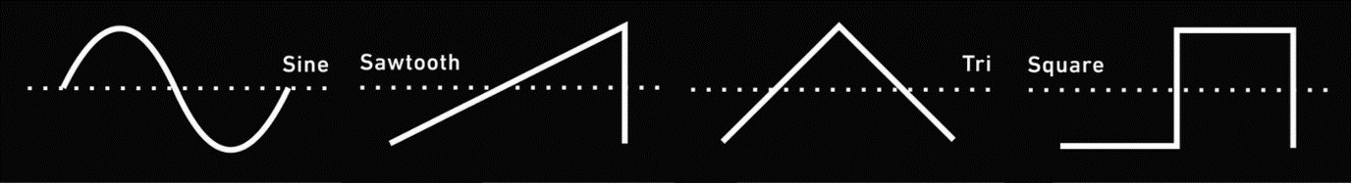

Figure 2.12 : A comparison of four wave shapes. On the x-axis: time. On the y-axis: voltage. Length of the waveshape: one cycle. unknown, Pinterest, <https://www.pinterest.com/pin/1009087860241726171/> [accessed and edited by Nikolaj Veljkovic 18 08 2024]

The function of a simple square wave oscillator can be demonstrated with the circuit in Figure 2.11. The main components are a variable resistor, a capacitor, and an inverting Schmitt trigger. The oscillation starts with the capacitor assumingly discharged (around 0V). This leads the inverted Schmitt trigger to output high, charging the capacitor through the resistor. Once the capacitor is charged, the Schmitt trigger switches to low, because the voltage at its input is high. Now, the capacitor starts discharging through the resistor, and once its voltage reaches the lower threshold the output of the Schmitt trigger goes low, completing one cycle [30, 31, pp. 114 - 118]. With the variable resistor it is possible to control how much of the current passes into the capacitor. The higher the resistance, the less current can flow, the slower the capacitor charges, the slower the oscillation, the lower the frequency. Resistance is therefore directly connected to the pitch and is used to control it [31, p. 118].

### VCF

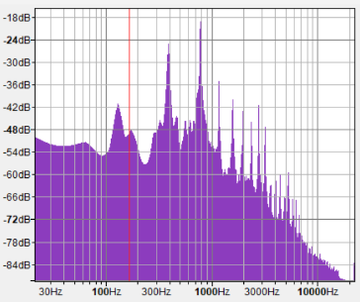

Figure 2.13 : A frequency analysis of the g note played on a piano. On the x-axis (logarithmic): frequency (Hz). On the y-axis: relative loudness in decibel (dB). Nikolaj Veljkovic, Audacity [created 27 09 2024]

When one hears a tone, it is never just a pure tone. When the string of a guitar swings, there are tones ringing over the fundamental frequency. The overtones, also called partials, are certain intervals away from the base tone [32]. There are no pure tones in nature, even frog noises contain overtones [33]. When looking at a frequency spectrum [Figure 2.13] of the middle g on the piano, multiple spikes are visible after that of the base tone. These spikes visualise the overtones.

As mentioned in sub-chapter 2.3.1, depending on a wave’s frequency, the pitch changes. Overtones are faster waves swinging with the fundamental wave. When multiple waves interfere, they can add to or subtract from each other. An addition of waves increases the amplitude without changing the frequency. In sound, this leads to an increase of loudness of the frequency [34]. Thus, the spikes in the loudness of certain frequencies are more waves swinging with the main wave, just at a faster rate.

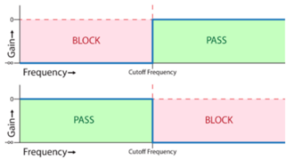

Figure 2.14: Idealised high pass (top) and low pass (bottom) filters. Scott Rise, The Synthesizer Academy: <https://synthesizeracademy.com/voltage-controlled-filter-vcf/> [accessed and edited by Nikolaj Veljkovic 12 10 2024]

A voltage-controlled filter (VCF) can cut off certain frequencies from the sound. It can be configured in multiple ways, of which the two basic configurations are a low pass and a high pass filter, respectively. A low pass filter cuts off the high frequencies, letting the low frequencies pass. The high pass filter cuts the low frequencies and lets the high frequencies pass [35].

A simple low pass filter [Figure 2.15] consists of a resistor and a capacitor. In the water analogy, the oscillation of the overtones can be seen as a sputtering of water through the pipe, which advances the rest of the waterflow (the lower frequencies). The resistor controls how much water (current) can pass the pipe at once. Instead of letting the sputter continue to the output, the capacitor acts as a balloon which the fast waves dribble into. This way, it fills up by catching the high frequencies. Because the capacitor is full, the low frequencies continue to the output without being disturbed. Once the wave has passed, the pressure in the pipe becomes smaller than that in the balloon and it will start discharging and pushing out the water [7, 36].

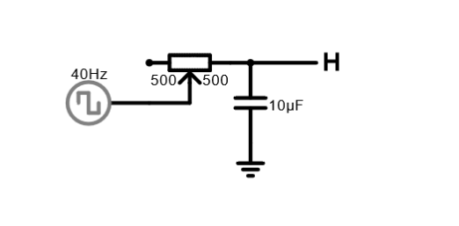

Figure 2.15 : The circuit diagram of a simple low pass filter. Nikolaj Veljkovic, Falstad: <https://tinyurl.com/25qle9ds> [created 30 09 2024]

Some overtones have thus been filtered out. By using a variable resistor, one can control how much water passes through to the balloon. The less water passes, the more slowly the balloon fills up, the more frequencies are filtered out [37]. For further information on how the wave shapes after a low pass and a high pass filter compare to one another, see Appendix 6.2.

### VCA

The voltage-controlled amplifier (VCA) is used to amplify the sound coming from the previous two modules. It controls the level (or loudness) of the incoming signal [38, 39].

“Gain” is used to quantify the amount of the amplification. It is the ratio between the output amplitude and the input amplitude. If the voltage at the input is 4V and the voltage at the output 12V, then the gain is 3. The higher the gain is, the louder one perceives the sound [40].

The gain of the amplifier is controlled by a control voltage (CV). A higher control voltage produces a louder output, whereas a lower control voltage creates a quiet output. An envelope [chapter 2.3.4] or a LFO [chapter 2.3.5] produces a voltage which can be used as a CV. By connecting these modules to the VCA, the loudness of the signal can be “modulated” [38]. Using modulation, effects such as tremolo or amplitude modulation can be achieved [41, 42].

### Envelope generator

Every sound has an envelope, which shows its change in loudness over time [43]. An envelope generator can generate a voltage in the shape of a specific envelope [38]. The most common envelope generator is the ADSR envelope generator [38, 44]. ADSR stands for some of the characteristics of a sound envelope: Attack, decay, sustain and release. The attack is how quickly after the beginning of the sound it reaches its peak. Decay determines how quickly it goes from the peak to a steady level. The steady level is the note while it is being played, called sustain. Finally, the release says how quickly the sound goes quiet after, for example, a key holding the note has been released [43]. In Figure 2.17 the same note played on a violin and on a piano are compared using an ADSR envelope.

Similar to the VCA, the envelope generator reacts to a CV. There are two types of CVs in an envelope generator: a gate and a trigger. A gate can, for example, come from a keyboard which produces a signal. When the key is pressed, the gate goes high. The attack stage starts. After it has reached its peak, it decays for a set amount of time, before it reaches the sustain level. As long as the gate stays high, the sustain will stay on the level it was set to. Once the key is released, the gate goes low. This releases the envelope which then goes low [38]. A trigger is just a very short gate. An envelope triggered by a trigger signal usually has no sustain [45]. The envelope generates an envelope in the form of a voltage. This leads to envelope generators being used as control voltage inputs for VCFs or VCAs [46].

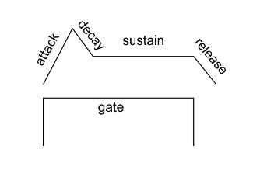

Figure 2.16: The influence of a gate signal on an envelope generator. unknown, Noise Engineering: <https://noiseengineering.us/blogs/loquelic-literitas-the-blog/getting-started-envelopes-vcas-and-attenuators/> [accessed 11 10 2024]

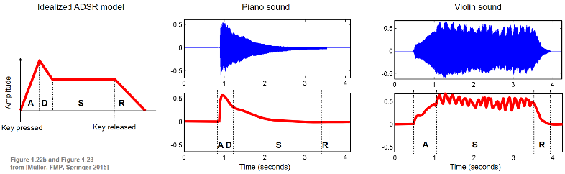

Figure 2.17 : The same note played on a piano and a violin - a comparison of the ADSR envelopes. Meinard Müller, AudioLabs Erlangen: <https://www.audiolabs-erlangen.de/resources/MIR/FMP/C1/C1S3_Timbre.html> [accessed 27 09 2024]

### LFO

At its core, the low frequency oscillator (LFO) is nothing else than a slow VCO. While the VCO oscillates in ranges which one perceives as pitches, the LFO oscillates at such a low frequency that humans cannot hear it [47].

LFOs are used to manipulate the modules mentioned in the previous sub-chapters. This process is called modulation [48]. An LFO could, for example, be hooked up to a VCF, whose cutoff point depends on the control voltage, provided by the LFO. When the control voltage input of the VCF is low, then almost the whole signal passes. When it is in a higher range, more of the frequencies get cut off. Similarly, the so-called “wah-wah” effect used with guitars is nothing else than a modulation of the filters cutoff point, only that guitarists usually do it with their own foot instead of an LFO [48, 49].

## Typical synth architecture

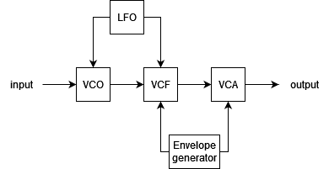

Figure 2.18: A typical synthesizer architecture. Nikolaj Veljkovic, <https://www.diagrams.net> [created 12 10 2024]

Every synthesizer is different, yet many possess commonalities. The architecture of a synthesizer describes what modules it is made of and in what order they are chained to each other. Usually, the first is the VCO. This makes sense: First, the sound has to exist before it can be modified. Cutting off or adding frequencies is done by the VCF. The LFO could be attached to either of these modules and modulate them individually. It could, for example, change the amount of cutoff over time or influence the pitch. The VCA amplifies the signal and can in turn be controlled by an envelope generator. The envelope generator could also modulate a VCF, for example by having the generator connected to the CV input of the VCF. [50].

# Process documentation

## Tools

After I had some idea of what a synthesizer does, it was time to start prototyping. Thanks to Sacha Di Piazza, who is my mentor and supervisor, I did not have to buy any materials. He gave me all the parts I needed, as well as tools and a power supply.

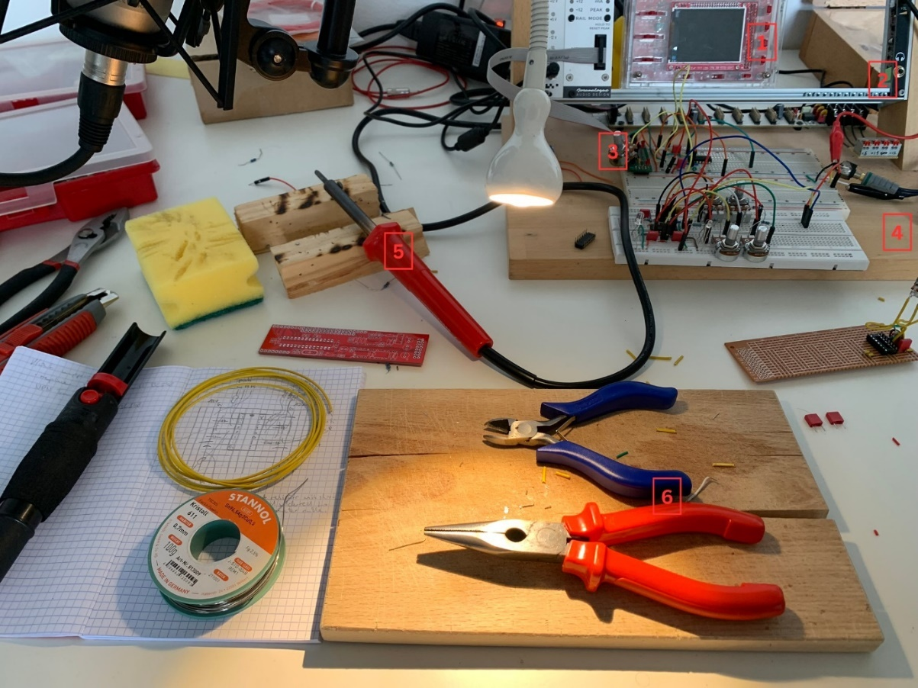

Figure 3.1: Tools I used while prototyping. Nikolaj Veljkovic [created 04 09 2024]

In Figure 3.1, one can see the tools I used while prototyping. The red box (1) is a digital oscilloscope. It displays the time on the x-axis and voltage level on the y-axis. The waveshapes in Figure 2.12 are displayed using the same method. It was incredibly useful in helping me understand how the oscillator behaves when I tweak or exchange certain components. The metal frame (2) is used to combine different modules. I only used it for the power supply, as my supervisor built a special power supply (3) which could be stuck directly onto the breadboard. On the wooden board (4) there is the prototype of the synthesizer, wired onto a breadboard. The soldering iron (5) is what I used later when soldering the board together. Number 6 are pliers, which were extremely helpful when I had to cut wires or pull off the isolation from the wire. In the upper left part of the picture, one can see a reading lamp. I transformed my microphone boom arm into a highly adjustable desk lamp. This was very useful when working in the dark or having to see something very tiny.

## Prototyping

Before I started building my synthesizer, I first had to know what a synthesizer is at its core. I had an idea of what synthesizers do, but I did not have the faintest idea how they did it. First, I read “Elektronik Basteln für Dummies” [51], which helped me understand some core elements of electronics. For the synthesizer logic, I read “Handmade Electronic Music” [31]. This phenomenal book opened my eyes to how simple some processes in the synthesizer actually are, and really motivated me to build one myself.

For every circuit diagram there is a picture in the appendix of what it looks like wired on a breadboard. Likewise, the circuit diagrams of the breadboard wirings and the finished synthesizer are also found in the appendix.

The breadboard is a board with holes in it under which metal strips pass. These strips are connected in a certain logic, such that it is easy to connect and combine different parts together, but also change and test combinations easily. The horizontal holes are linked together, and the vertical holes (marked red and blue) are also interconnected and usually used for positive and ground supply. The line in the middle divides the horizontal lines into two. It serves an in important use, as many integrated circuits are built to fit onto a breadboard. Each individual leg of the IC should have its own line where other components can be connected to. Therefore, an IC can be easily stuck in the middle of the breadboard [52]. In the special power supply I used, the two upper power lines were +12V and +5V, and the two lower power lines were GND and -12V.

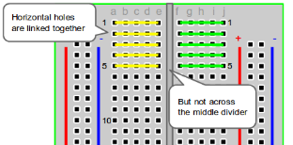

Figure 3.2 : Breadboard wiring. Ben Miller, EnvatoTuts+: <https://computers.tutsplus.com/how-to-use-a-breadboard-and-build-a-led-circuit--mac-54746t> [accessed 02 10 2024]

The square wave oscillator is a very basic one. Following a guide in “Handmade Electronic Music” [31, p. 116], it was surprisingly simple to build: The only parts required were a 10nF capacitor, a 100kΩ resistor and a HEF40106BP, which has six inverting Schmitt triggers. The joy I felt at the screaming sound out of my first VCO was incredible. One can see how this simple oscillator is configured in Figure 3.3.

The problem with this design is that it is not very user friendly. It produces the same sound in the same pitch all the time. To change this, I substituted the normal resistor with a 100kΩ variable resistor. It can go from 100kΩ to 0Ω resistance. Because of this, I had to add a small pre-resistor of 1.2kΩ to prevent frying the circuit when the variable resistor let all the current pass. With a dynamically changeable resistance I could change the pitch of the sound as I wished. By changing around the value of the capacitor and resistor, I could choose the range I wanted my sound to be in. The low range pleased me a lot, so I chose a big resistor. But I still wanted to be able to have some squeaky sounds, so I had to have a small capacitor which could charge quickly. I chose a 100kΩ variable resistor and a 220mF capacitor.

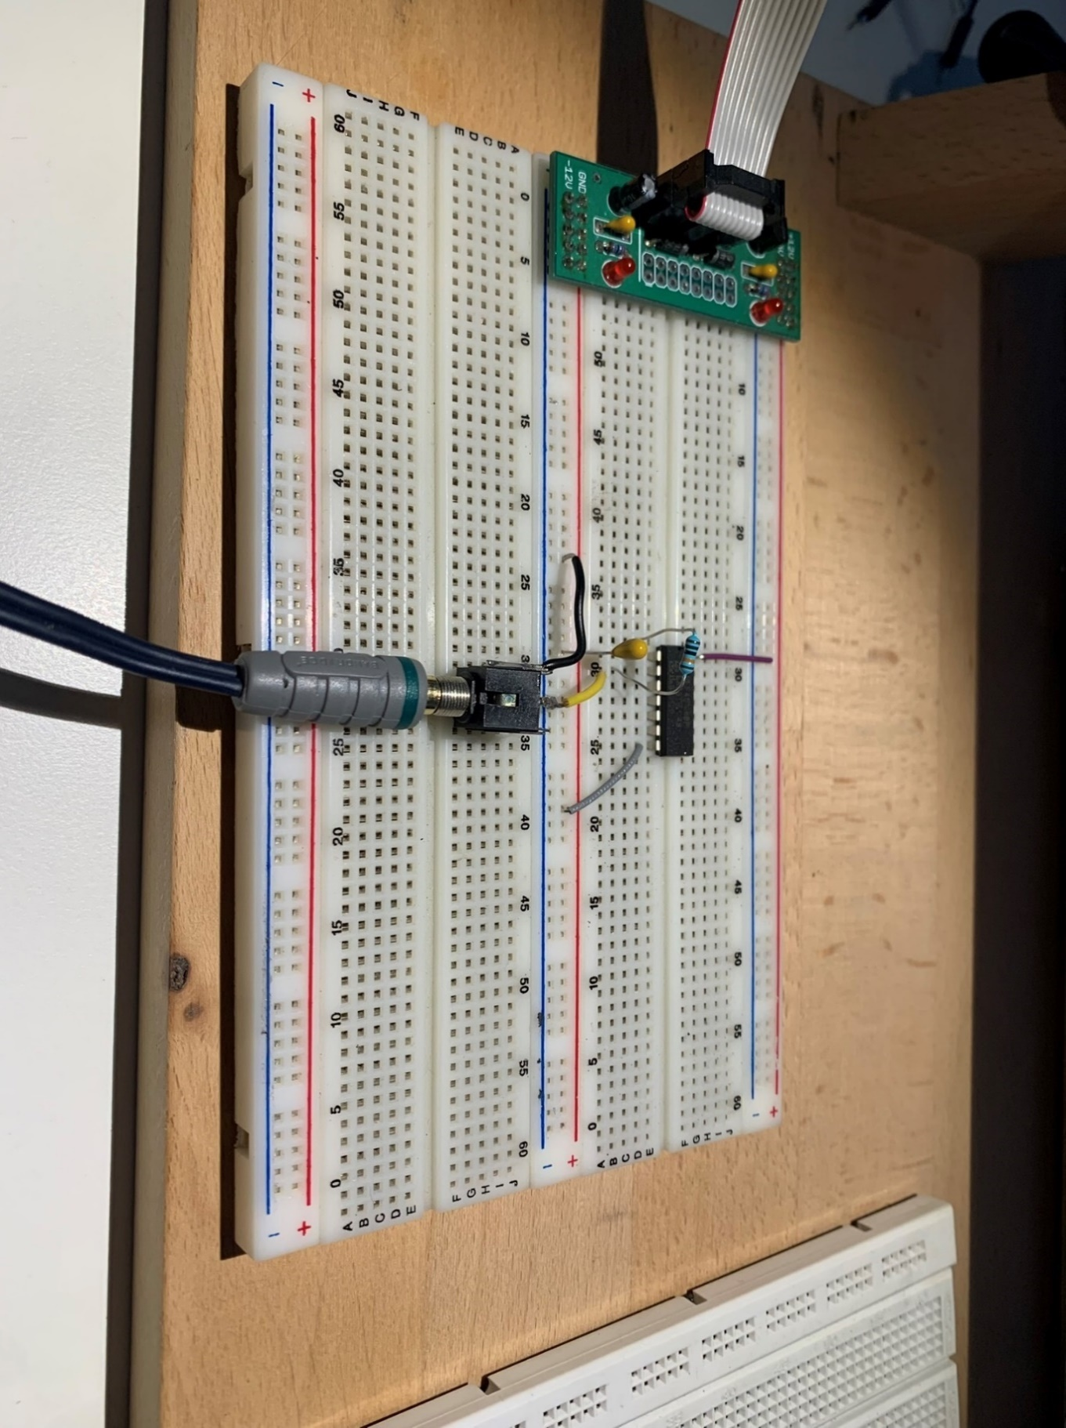

Figure 3.3 : A simple square wave VCO. Nikolaj Veljkovic [created 11 06 2024]

Being satisfied with the result of one oscillator, I added a second and later a third based on the same architecture. In Figure 3.4 one can see three similar oscillators. The two upper ones pass through a summing resistor before going into the jack output. A summing resistor is a resistor that is put before the different signals are mixed, to prevent the signals from interfering with each other [53]. I did this to see if it changed the stability of the sound in any way. As a matter of fact, it lowered the volume of those channels and removed some of the noise. The volume was lowered because the resistor limits the current from passing and there is nothing equalising that voltage drop [54]. The third oscillator passes through a low-pass filter before going through the summing resistor and then into the output. The low pass filter works as described in chapter VCF2.3.2. It has a 10nF drain capacitor and a 100kΩ resistor. This gave me a good idea of how far down I wanted to set the cutoff frequency. It allowed me to play around with different sounds, but it was not very dynamic. Therefore, I substituted the static resistor with a variable one, which now enabled me to cut off the high frequencies as I desired.

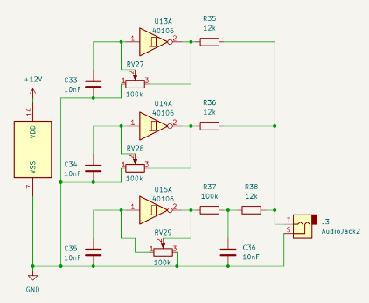

Figure 3.4: Three VCOs. Nikolaj Veljkovic [created 04 10 2024]

I wanted to test a different kind of square wave oscillator, because I got inspired by a design in “Handmade Electronic Music” [31, p. 132]. The IC I used for it is the CD4011, and it consists of four NAND gates. I coupled two NAND gates together by taking the output of the first and connecting it to the input of the second. The first input of the first NAND gate is a feedback loop consisting of a capacitor going to ground and a variable resistor. The second input is directly 12V. One input of the second NAND gate is the first NAND’s output. The second input is again a feedback loop like in the first NAND gate. As the capacitor and the first input oscillate by themselves, this leads to interesting sounds. I did the exact same thing with the remaining two gates in the IC. This way, I had two oscillators, each consisting of two coupled NAND gate oscillators. The two signals pass through summing resistors before being mixed at the output [Figure 3.5].

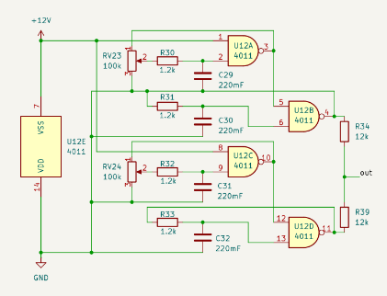

Figure 3.5: First NAND oscillator design. Nikolaj Veljkovic [created 04 07 2024]

At first, I only put a variable resistor in the first stage of the oscillator. My expectation when combining the two sources was to hear two separate oscillators, like two flutes playing together. Instead, it was one mixed sound. Turning one knob influenced the sound as a whole, even though the oscillators were only connected at the output.

To go even further, I replaced the static resistors in the second stage of the oscillators again with variable resistors [Figure 3.6]. I had the feeling that one oscillator manipulated the other now even more. To test this, I attached the oscilloscope. What I found astounded me: They were influencing each other! When both oscillators were slow, the square wave was very wide. However, if one oscillator was slow and the other fast, the fast one played only when the square wave of the first one was high. This phenomenon probably has to do with my circuit not being perfect. Somewhere the electricity might have been leaking into the other oscillator, which made them influence each other. I did not mind this at all, though. I even liked the sound and, to some extent, the unpredictability of it. It also made the picture on the oscilloscope very captivating to look at.

Figure 3.6 : Second NAND oscillator design. Nikolaj Veljkovic [created 04 07 2024]

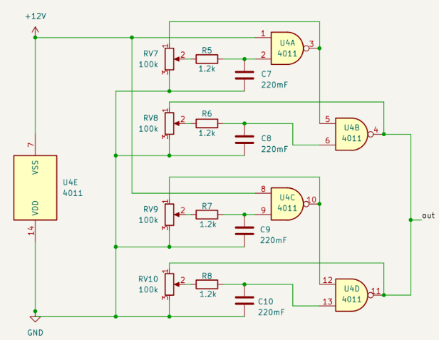

Next, I played around with buffers. It is important to note that “playing around” was the main approach in this process. This in turn led to many prototypes not working properly. Either because of my lack of knowledge, or because of a mistake I did not notice. Therefore, there was a lot of trial and error involved in the process of building this synthesizer.

I wanted to have a buffer before the signal went into an AC coupling and then a filter. Therefore, I used a NE5532AP chip with two op amps in it. At first, I only had one buffer stage before a low pass filter. I wondered if anything had changed when there were two consecutive buffers. Maybe it would have, but in my case no signal passed. It could very well be that the IC was broken, as in the final model had working consecutive buffers. In Figure 3.7 one can see the schematic circuit with two consecutive buffers.

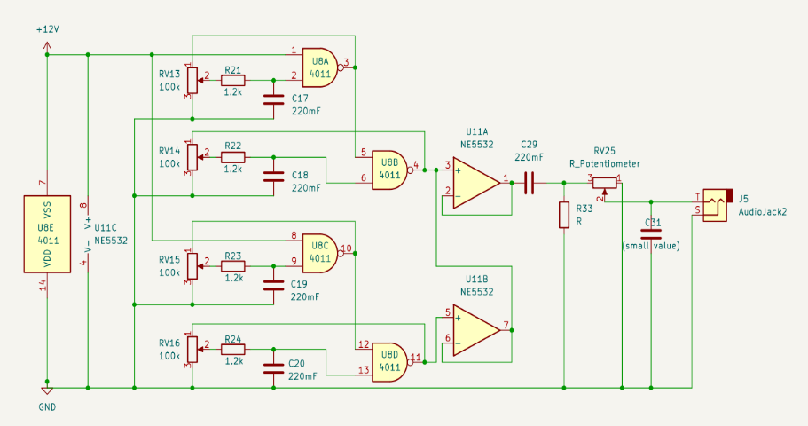

Figure 3.7 : Two-stage buffer into an AC coupling into a low pass filter. Nikolaj Veljkovic [created 04 07 2024]

Most of the process considering the oscillator happened during the “Intensivwoche”. I had built a little office in a classroom, which kept me motivated, and I could sit and work there for hours. But starting from this next segment, I did not have the comfort of a dedicated workplace anymore. Instead, I set up a home office.

After having figured out what my sound source was supposed to be and sound like, I had to figure out the next step: filtering. In the chapter 2.3.2 an ideal filter was described. A filter has a cutoff point, from where on it starts to cut frequencies off. However, this cutoff point is not perfect, as it does not strictly cut off all the frequencies from that point on. Instead, there is a curve after the cutoff point, before the filter actually cuts a whole frequency out, as seen in Figure 3.8. Two consecutive filter stages improve the cutoff of the overall sound. The cutoff efficiency of a filter can thus be categorised into so called “orders”. One filter stage is a “filter of the first order”. Two filter stages are a “filter of the second order”, and so on. It is practically impossible to have a perfect filter, only getting very close to the ideal cutoff point is possible [55].

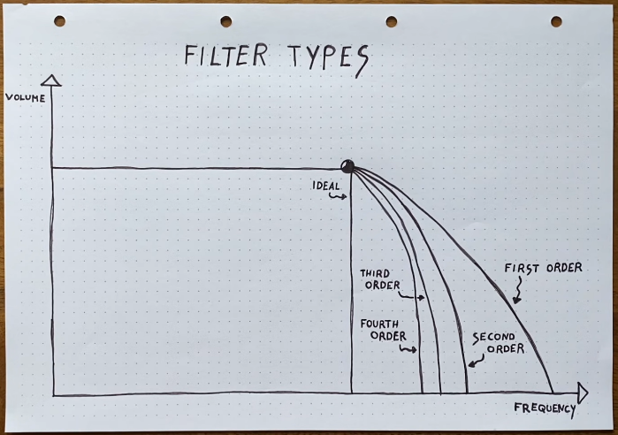

Figure 3.8 : Orders of filter stages. Moritz Klein, youtube.com: <https://www.youtube.com/watch?v=3tMGNI--ofU&list=PLHeL0JWdJLvT1PAqW4TtvxtRoXyk741WM> [accessed 30 09 2024]

Having this in mind, I decided to make a second order filter. For this to work out, I needed two consecutive filter stages. The challenge was to set the cutoff frequency of both filter stages simultaneously. There is no use in a two-stage filter when one stage does not filter at all. Luckily, dual variable resistors exist. They are a 2-in-1 solution, one knob controlling two variable resistors. In Figure 3.9 one can see what it looked like after I soldered wires onto it (I later added the two missing ones). Using this, I was able to control both filter stages simultaneously, and the difference was enormous. The filter cutoff was steeper, which means that it cut off more of the high frequencies, and the sound was cleaner.

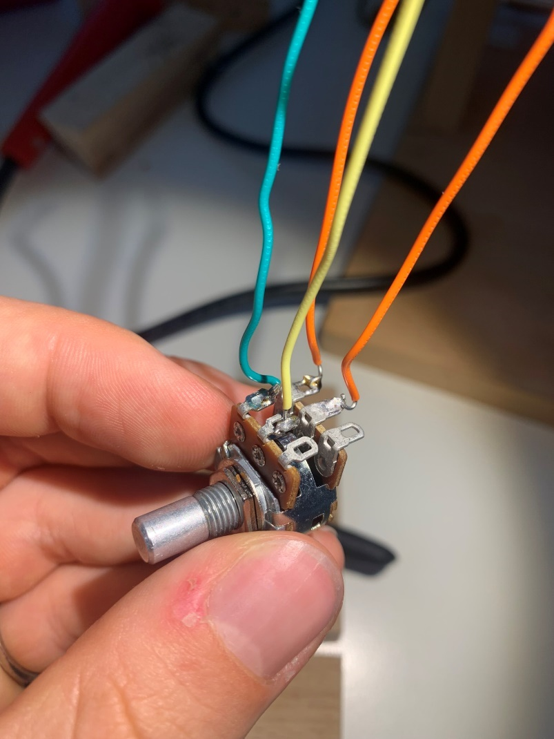

Figure 3.9: A dual variable resistor. Nikolaj Veljkovic [created 21 08 2024]

However, a new issue came up: The lower the cutoff frequency, the quieter the signal became. This is because the second filter stage only gets some of the signal after the first filter stage. There is nothing separating the two and therefore current only “leaks” through to the second filter stage [23]. Here, a buffer comes in handy. It can separate the two stages but still provide the same voltage by “following” it [23]. I thus added one buffer after the first and one after the second filtering stage [Figure 3.10].

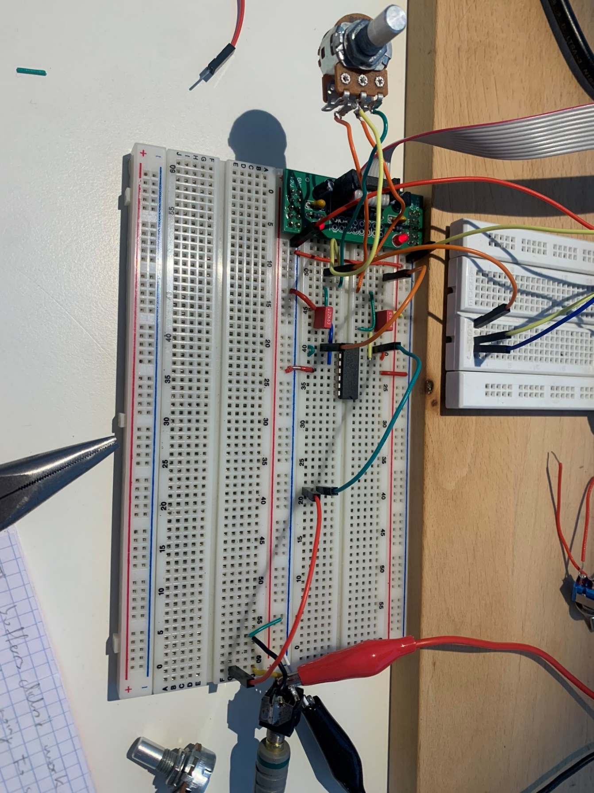

Figure 3.10 : Filter-buffer-filter-buffer and a dual variable resistor. Nikolaj Veljkovic [created 23 08 2024]

## Soldering

While a breadboard is useful in prototyping, it is not ideal for a prototype or finished product. The holes in the board make it prone to wires falling out and its size is not ideal. That is why protoboards and printed circuit boards (PCBs) exist. They come in varying shapes and sizes, can be custom printed and the components are soldered directly to the board. Due to their compact nature, all modern electronic equipment uses PCBs for mounting electronic components. In the case of protoboards, which are designed to facilitate the making of prototypes, the connections between individual components need to be made manually. Many protoboards have copper strings on the bottom of the board. These are like the connections on a breadboard: When two parts are soldered onto the same strip of copper, they are connected [56].

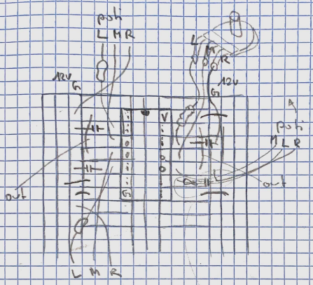

Figure 3.11: Sketch of protoboard before soldering. Nikolaj Veljkovic [created 05 09 2024]

Going from a breadboard to a protoboard was much trickier than anticipated. Because there were a lot of pieces that had to be crammed into a tight space, I spent a lot of time planning the layout [Figure 3.11].

At first, I soldered wires onto the variable resistors. As mentioned in chapter 3.2, a variable resistor has to be accompanied by a pre-resistor, so that the circuit does not get shorted when the variable resistor is at 0 resistance. Because of space limitations, I soldered the resistor directly to the wire connected to one of the legs of the pot [Figure 3.12].

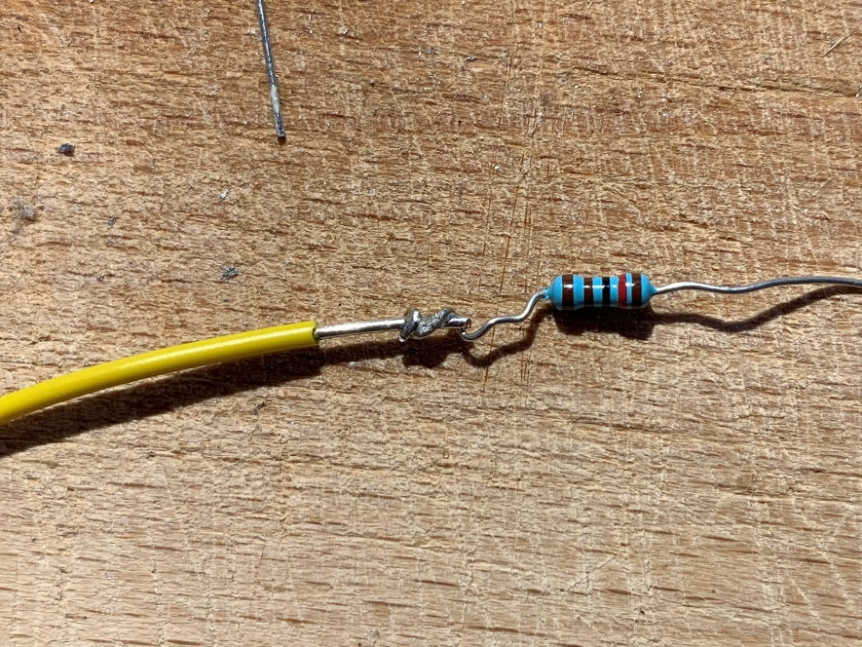

Figure 3.12 : A resistor soldered to a wire. Nikolaj Veljkovic [created 04 09 2024]

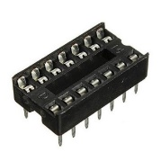

Figure 3.13 : An IC socket. unknown, Amazon: link [accessed 30 09 2024]

The first thing I soldered onto the board was an IC socket. As the name says, it can hold an IC and is used for easier replacement in case the IC were to malfunction [57]. After, I soldered the capacitors and wires. The variable resistors came last, as they have wires which could be fit into a tight space, when all the other parts were already soldered.

By no means did the soldering go smoothly. Several times I soldered something into the wrong hole, soldered two wires together that were not supposed to touch, burnt some copper off the back side of the board and even burnt myself once. This usually meant that I had to re-solder parts into other holes. To some extent, these mistakes happened due to my lack of concentration, but some were also because of bad equipment. I am not very proud of my soldering, but it did the job. In Figure 3.14 one can see the Battlefield of Solder.

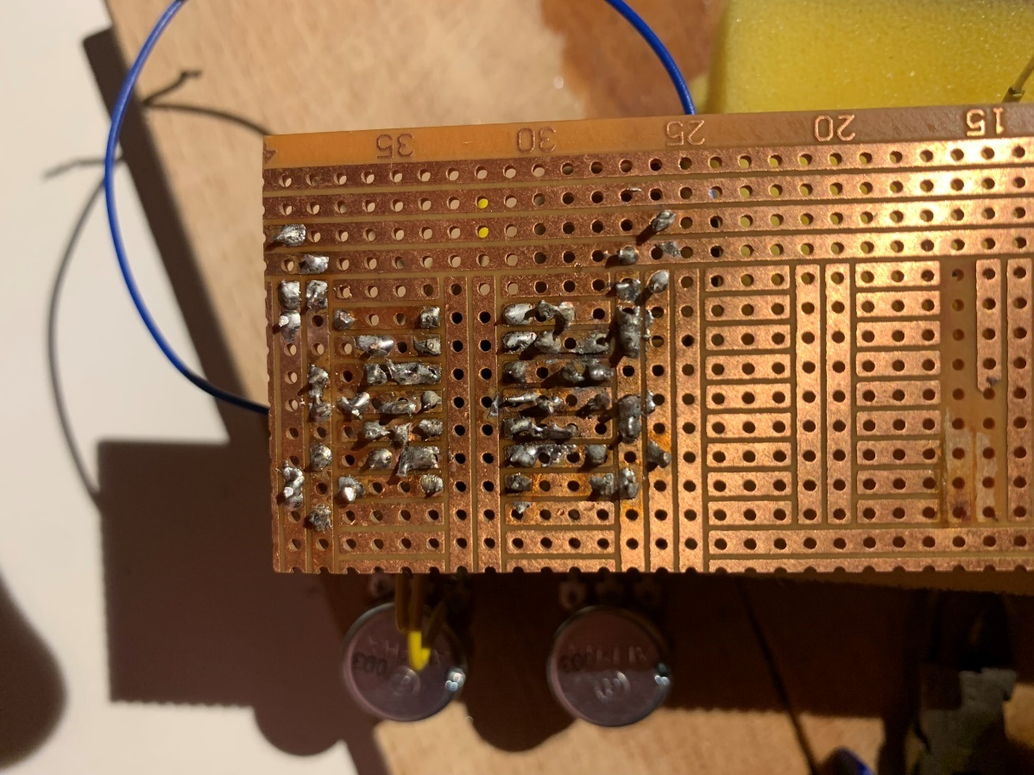

Figure 3.14 : Back side of the VCO module. Nikolaj Veljkovic [created 06 09 2024]

I had intentionally cut longer wires than I needed for the variable resistors. Because of this they look all wrinkly and weird. The wires being long allowed me to turn them in any direction, leading to more flexibility. Next, I added wires for the audio output and two cables for the power supply. To remember which cable was ground, I marked it with black isolation tape. I hooked up the oscillator to a power supply and the cables with my amplifier. It worked! The sound was not exactly the same as on the breadboard, but it responded similarly to the input. After having successfully completed the oscillator it was time to solder the filter.

Soldering the filter turned out a little complicated. Some of the copper was missing in the planned space, so I had to be creative and wire it a bit uglier than planned. The major challenge, however, was soldering the dual variable resistor. Keeping the wires in their holes while the board was on its head was quite tricky. But after some pushing and stabilising, I managed to solder it in.

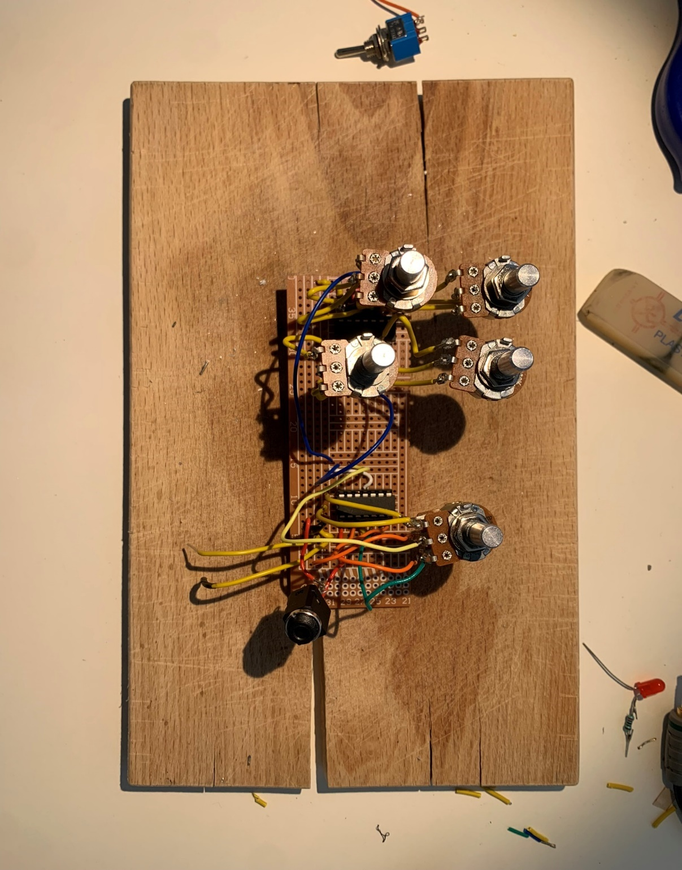

Figure 3.15 : The finished circuit board. Nikolaj Veljkovic [created 13 09 2024]

After connecting the audio wires from the oscillator to the input of the first filtering stage and adding an audio jack, I tested the circuit. It worked! Although it did cut out sometimes, it worked. I did not think it would after having re-wired and de-soldered it so often.

## Building the case and assembly

For the case, I knew from the beginning that it should be in a box. I liked the idea of having a somewhat “rough-looking” synthesizer, on which I could put my own handwriting. For a long time, however, I could not find anything that pleased my imagination exactly. In the end I chose an old perfume box because it had a shape and size which could fit the synthesizer.

In Figure 3.19 there is the rough drawing of the layout I wanted. Before, I had only once roughly sketched a layout in my notebook with a somewhat different vision [Figure 3.18]. I put the variable resistor with the knob on the top of the box and drew a rough circle where it should pass through. The plan was to drill a hole and then stick the knob of the variable resistor through from below. I did the same process for the other four as well. Then, I drilled the holes on my balcony, as this is the closest I have to a work bench at home [Figure 3.17]. Before putting the variable resistors through the holes, I wanted to colour the lid.

The colouring was quite simple, but time consuming. It was not possible to colour onto the box directly, as the print would not allow for it to be even. Thus, I taped it with yellow tape [Figure 3.16]. This gave the synthesizer its weird, uneven look. With the support of my mother, saving time and bonding simultaneously, the case was coloured with a dark blue marker.

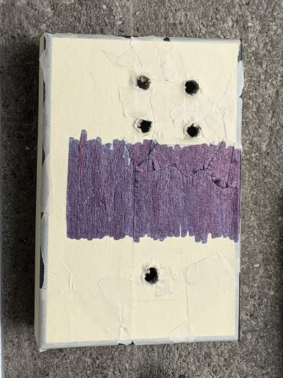

Figure 3.16 : Colouring the lid. Nikolaj Veljkovic [created 13 09 2024]

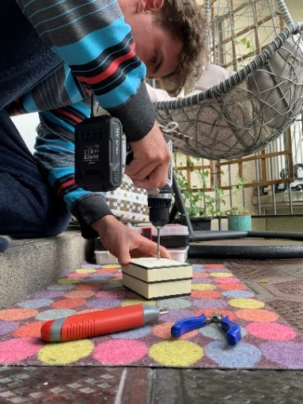

Figure 3.17 : Drilling holes. Nikolaj Veljkovic [created 13 09 2024]

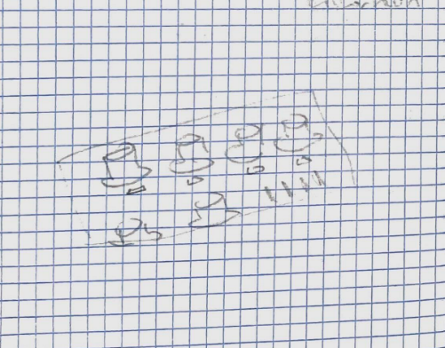

Figure 3.18: Weird layout sketch in notebook. Nikolaj Veljkovic [created 04 08 2024]



Figure 3.19 : Rough sketch. Nikolaj Veljkovic [created 13 09 2024]

The variable resistors I used have a nut screw, which can be taken off. They also have a small bit of metal standing out, assumingly used to fix the variable resistor in its position [58]. I could not use that, and it made the positioning of the variable resistor quite difficult. So, I broke it off [Figure 3.21]. After putting the knob of the variable resistor through the hole, I screwed it tight with the nut screw I had taken off before.

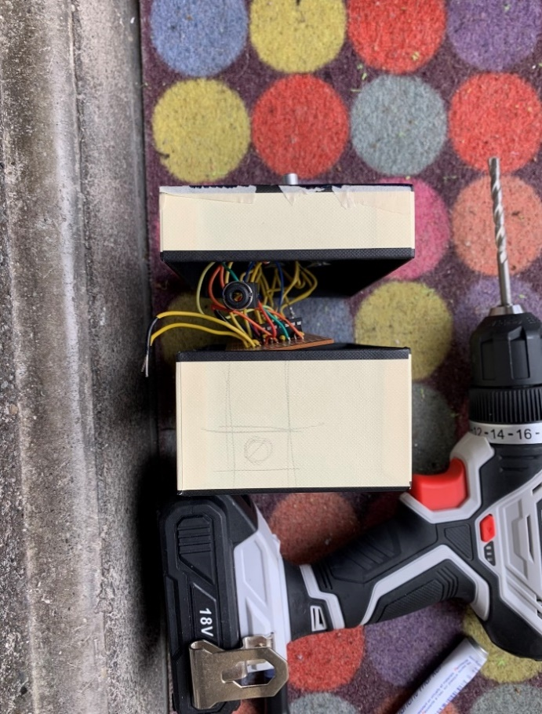

Figure 3.20 : Planning the location of the audio jack hole. Nikolaj Veljkovic [created 13 09 2024]

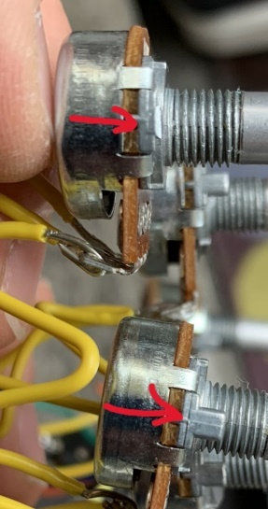

Figure 3.21 : The unnecessary metal part. Nikolaj Veljkovic [created 13 09 2024]

A mistake I made while drawing the design was that I did not account for the size of the body of the variable resistor. This led to me having to squeeze them together and even put a sheet of isolation tape in between, because the metal was touching.

Up to that point, I had not drilled the holes for the audio output and the power supply. I did not know where they would exactly be when I put the variable resistors in the cover of the box. After screwing the variable resistors into the lid, I could draw in the position of the audio jack and power supply [Figure 3.20].

To colour the body of the box I used the same process as with the lid. The most difficult of all I had done up to now was getting the audio jack through the hole. It was impossible for me to pull it through the hole without putting the lid on, which in turn meant I could not move the audio jack. I solved it by threading a thin audio cable through the hole and sticking it into the jack input. When the box was closed, I had to pull extremely slowly, to not yank the cable out. After several tries, the help of my mother’s thin fingers and cries of frustration, we managed to push it through the hole. I stabilised it with a round nut screw, similar to the variable resistors. For the power supply I wanted to make two thin holes. Unfortunately, I pushed a little too hard while drilling, which made a bigger hole than required. I decided to put both power wires through one hole. One can see what it looked like in the end in Figure 3.22.

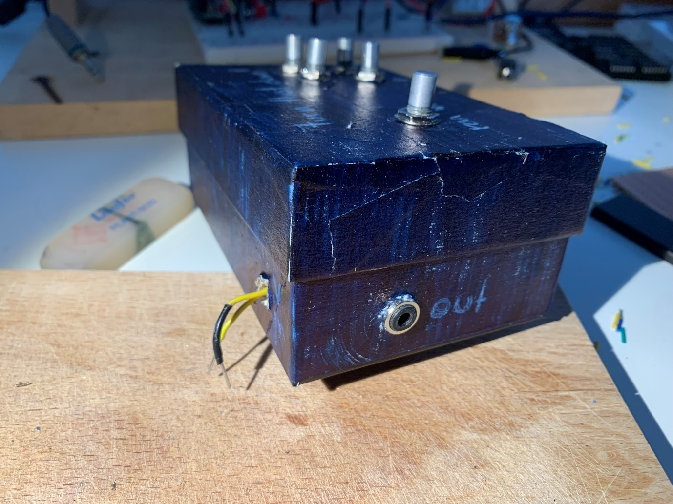

Figure 3.22 : The two side-holes. Nikolaj Veljkovic [created 13 09 2024]

Satisfied with the look of the synthesizer, I decided to test it. I attached the two wires to the 12V power supply and hooked up a speaker to the audio jack. Immediately after turning on the power, the synth came to life. However, I quickly realised that something was wrong.

The oscillator knobs did not react as they did in the previous test. And instead of the filter cutting off frequencies, it randomly either turned the whole sound off, or changed the pitch. I was very unhappy, but due to my tight schedule I could not go back and fix the issue. Luckily, I had not labelled the synthesizer yet.

I had been playing around with names for a while, but “turn that down!” was the one that I liked the most. It was what my mother told me after hearing the sound of it for the first time. Using a white crayon, I wrote the name on the top of the synth. I intentionally wrote it very weirdly to match the already rugged appearance and the weird sounds. The knob which was once a filter got named “random”, and the oscillators became “pitch”. I also wrote “out” next to output jack and “V in” next to the power supply cables.

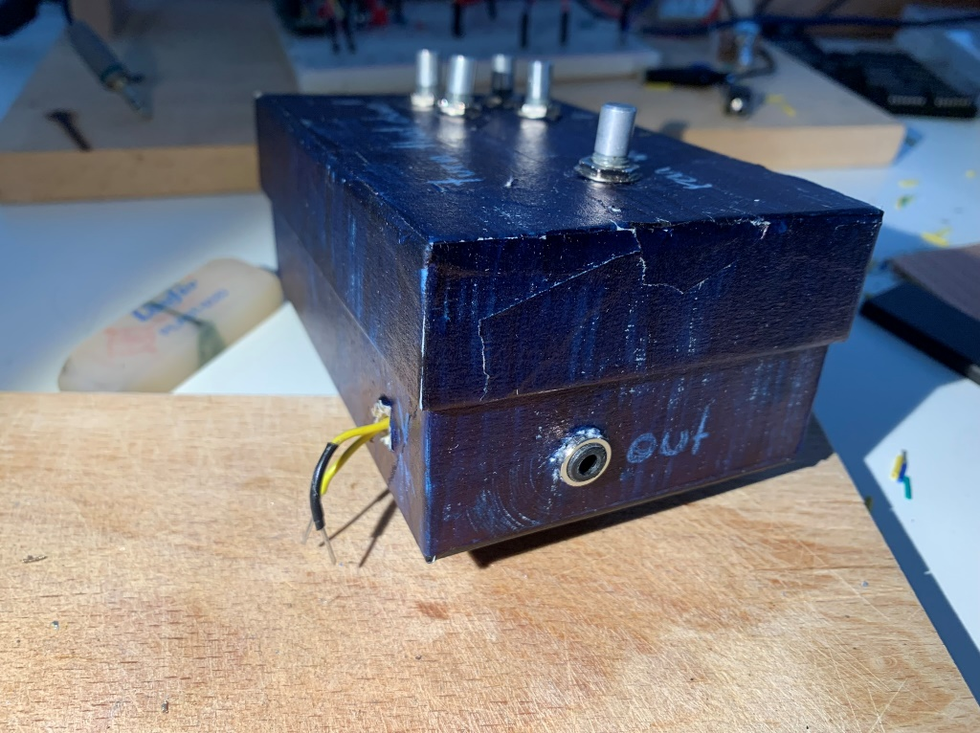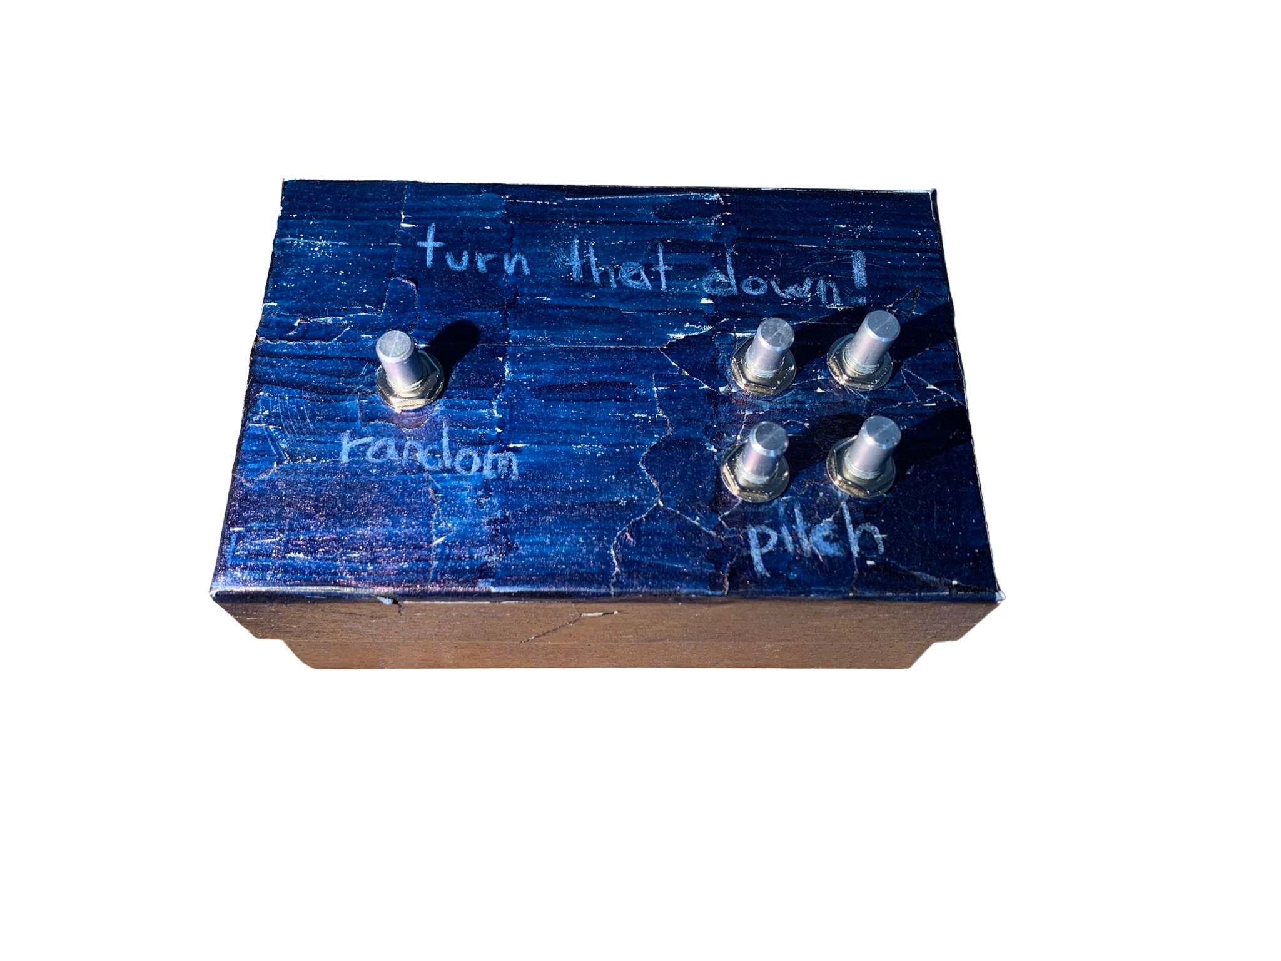

Figure 3.23 (top), Figure 3.24 (bottom): The finished synthesizer. Nikolaj Veljkovic [created 13 09 2024]

# Critical analysis and improvements

I enjoyed working on the synthesizer a lot and it sparked my interest for electronical engineering. However, there are many things that I could have improved.

To start off: motivation and focus. It was often hard for me to start working. Even though I could get lost in the work, pushing myself to start was very difficult. For my next paper I will have to implement a system which makes it easier for me to start working. While writing the paper, I used the pomodoro method, which proved to be very effective in my workflow. Taking a five-minute break every 25 minutes gave my brain the possibility to catch some air and allowed me to focus on the task again. More often than not, I realised something during a break that I would not have otherwise. When I was very stressed and I couldn’t write at all, I focused on something different, like physical exercise. This helped me clear my mind. Transferring my “office” to school also helped out a lot, as the different environment helped me focus much more on the task ahead.

Not until it came to correcting had I realised that basically every sentence had to be proven by a source, especially in the theory part. A lot of stuff I said was something I remembered vaguely from reading or hearing about it somewhere, and just wrote it down. The aftermath was, obviously, horrible. I had to go through all of the text and find sources which would support what I wrote.

During prototyping I should have kept a more rigorous journal of my work, which would have helped me after a longer break when I forgot what I had done in the past work session. It would have also helped had I researched more before starting out with building the synthesizer. For example, the two oscillators influencing each other is not anything weird or uncommon and not even a faulty circuit. This is to be expected when two waveshapes are mixed and the frequency of one is changed. Had I known this beforehand, I would not have jumped to false conclusions. Even my oscillators and filter were not actually a VCO and a VCF. They were not controlled by a voltage, as the name implies, but by potentiometers. I also marked the power supply wires with “V in”, which does not make much sense, as the voltage is not only going in. It would have been better to simply mark it as “power” or just “V”. However, this can also be traced back to bad time allocation.

Better equipment could have made soldering easier. The tip of the soldering iron I used was very dull and not suitable for exact work. I was also missing steel wool to clean the soldering iron before and after usage, which had an influence on how well the solder melted.

I had to finish building my synthesizer almost five weeks before the due date of the paper, as I was not going to be home during the prolonged autumn vacations. Because of my very optimistic time schedule I had already planned to be done at that point. I was nowhere near having a finished VCO or VCF, so I converted what I had into a finished product.

On a more positive note, a good thing I did was that I usually summarised the different functions of ICs in a notebook. This meant I did not have to go and search for that information over and over again in the datasheet but could just open up my notes.

Throughout this process, I learned a lot. Not only did it open my eyes to the immense world of analogue synthesizers, but also to electronical engineering in general. Using the knowledge I gained, I would like to build more synthesizers and improve the basic skills I’ve gained.

For the next version of the synthesizer I would like to upgrade the modules to be voltage-controlled, as well as a keyboard. This will upgrade the synthesizer from a noise maker to a musical instrument.

# Acknowledgments

First of all, I would like to thank Sacha Di Piazza for his guidance and mentorship. His patience while answering my questions and his interest in helping me was invaluable. Further, I would like to thank Peter Künzler for the help with questions regarding grammar and language. A special thank you goes to my mother who helped me with the assembly of the synthesizer. My friends supported me by distracting my mind away from the matura paper, which I am most grateful for.

# Appendix

I have created a GitHub site for the whole project. There, all the images, schematics, scans, and the paper itself can be found. Even more, there are videos of the prototypes and a demonstration of the final product. Find the project under <https://www.github.com/nikja05/MA-turn-that-down>

## Additional Images

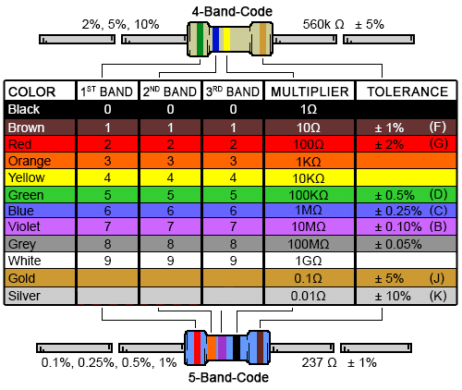

Appendix 6.1: A resistor colour chart. unknown, DigiKey: [https://www.digikey.com/-/media/Images/Marketing/Resources/Calculator/resistor-colorfigurechart.png?la=en-US&ts=4db603f5-4e9b-4759-84b7-21a04d18b1a8](https://www.digikey.com/-/media/Images/Marketing/Resources/Calculator/resistor-color-chart.png?la=en-US&ts=4db603f5-4e9b-4759-84b7-21a04d18b1a8) [accessed 29 09 2024]

Appendix 6.2: From left to right – Clean square wave, low-passed square wave and high-passed square wave. Nikolaj Veljkovic, Falstad: <https://tinyurl.com/2985fpd9> [created 30 09 2024]

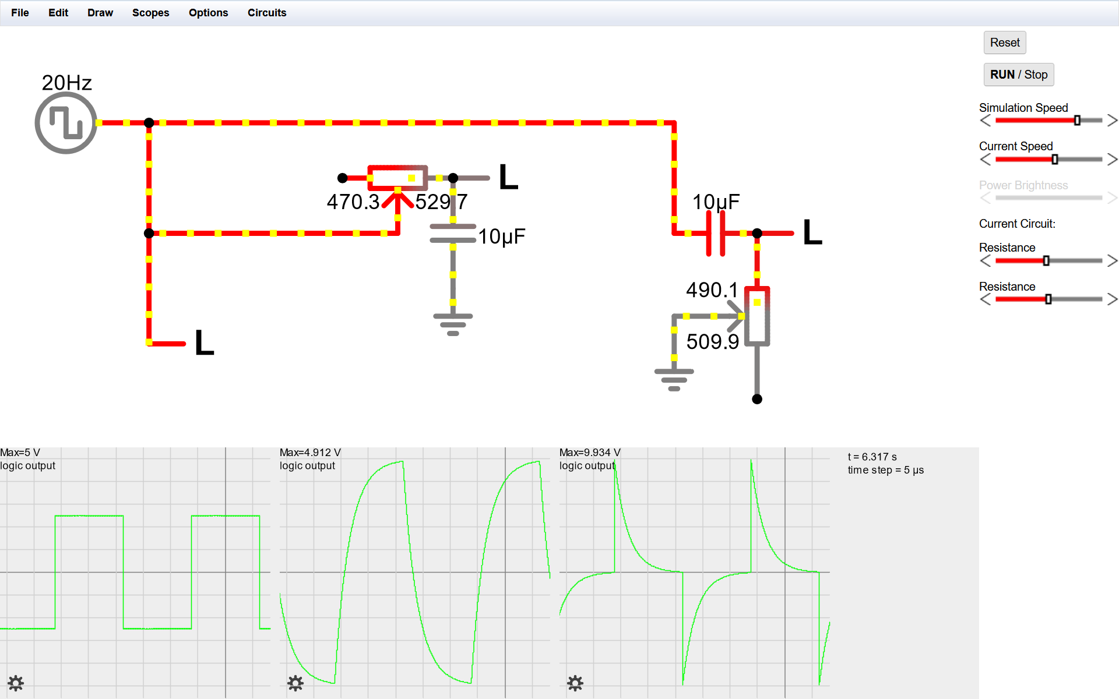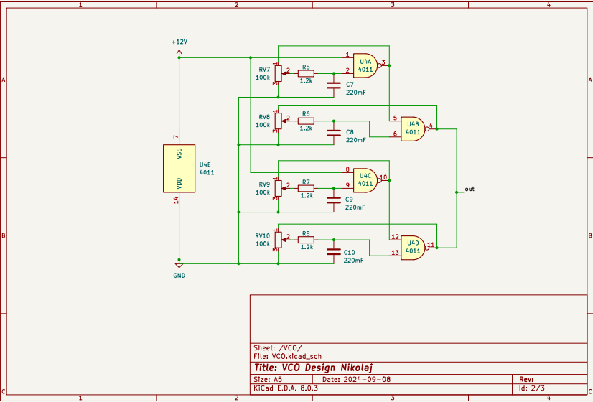

Appendix 6.3: Circuit diagram of the oscillator. Nikolaj Veljkovic [created 15 10 2024]

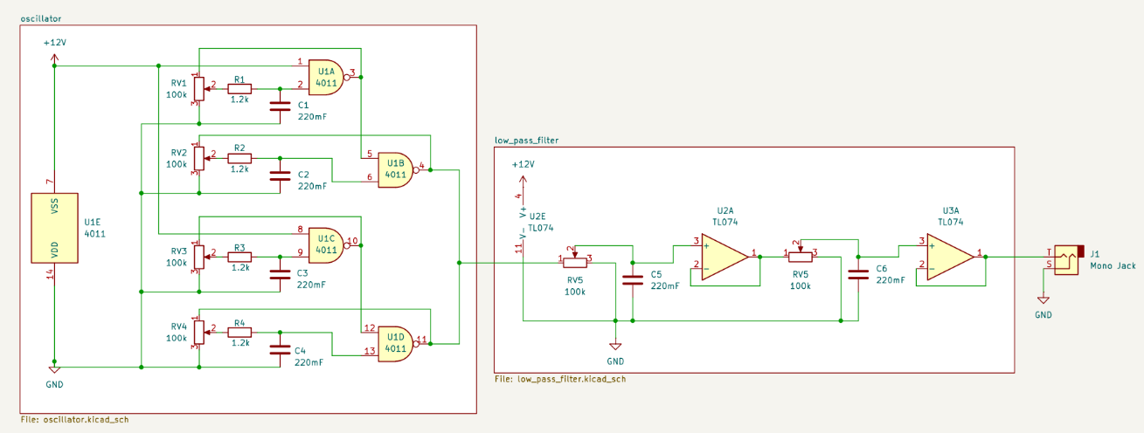

Appendix 6.4: Circuit diagram of the finished synthesizer. Nikolaj Veljkovic [created 15 10 2024]

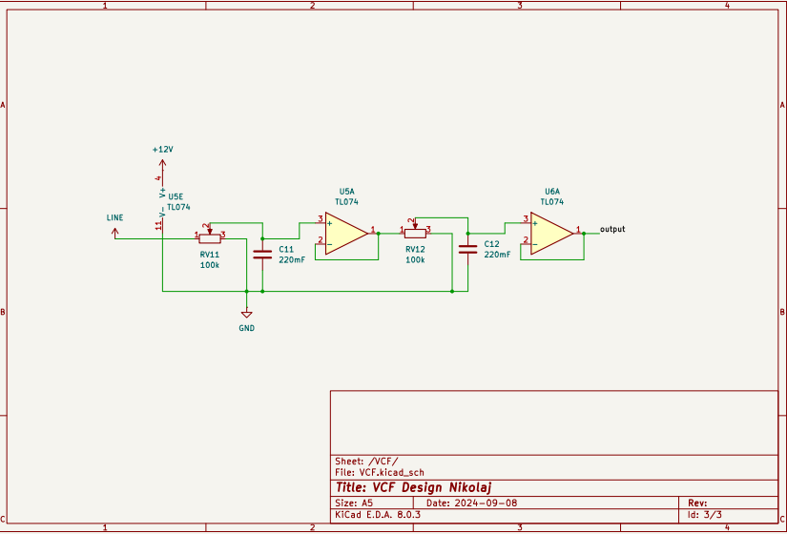

Appendix 6.5: Circuit diagram of the oscillator. Nikolaj Veljkovic [created 15 10 2024]

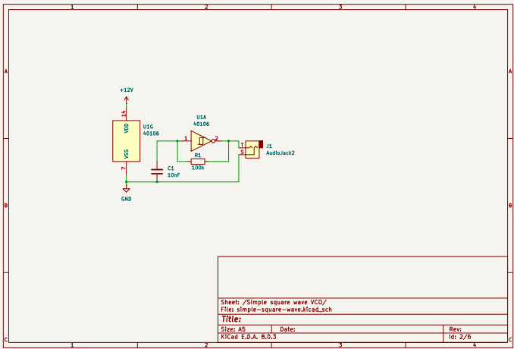

Appendix 6.6: Circuit diagram for the first oscillator design. Nikolaj Veljkovic [created 15 10 2024]

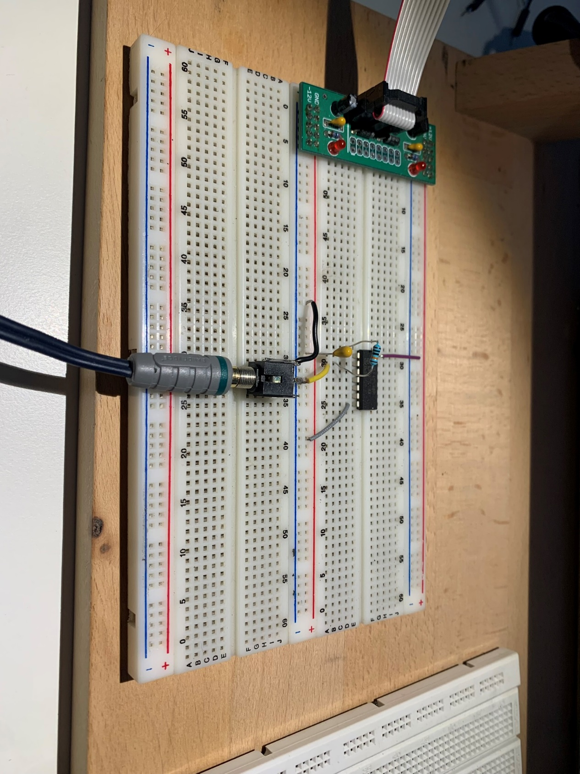

Appendix 6.7: Breadboard wiring of the simple square wave oscillator. Nikolaj Veljkovic [created 02 07 2024]

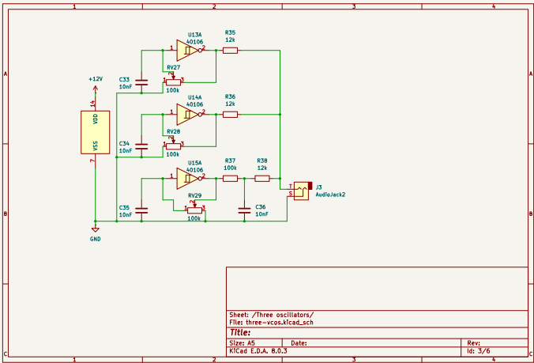

Appendix 6.8: Circuit diagram of the three oscillators. Nikolaj Veljkovic [created 15 10 2024]

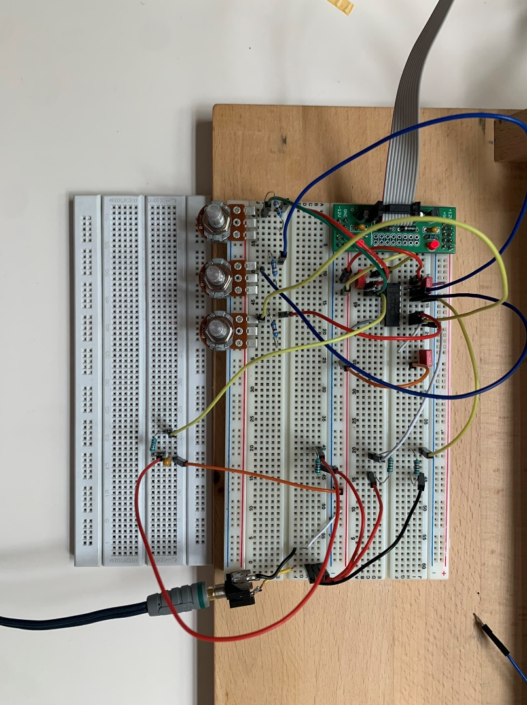

Appendix 6.9: Breadboard wiring of the three inverting Schmitt trigger oscillators. Nikolaj Veljkovic [created 03 07 2024]

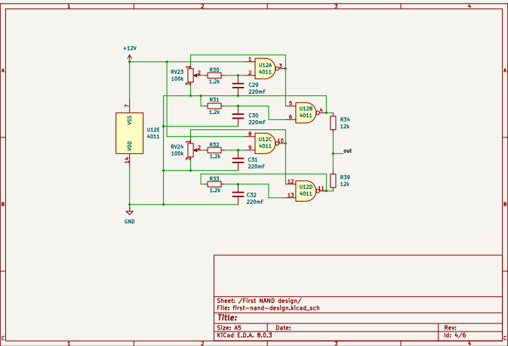

Appendix 6.10: Circuit diagram of the first NAND oscillator. Nikolaj Veljkovic [created 15 10 2024]

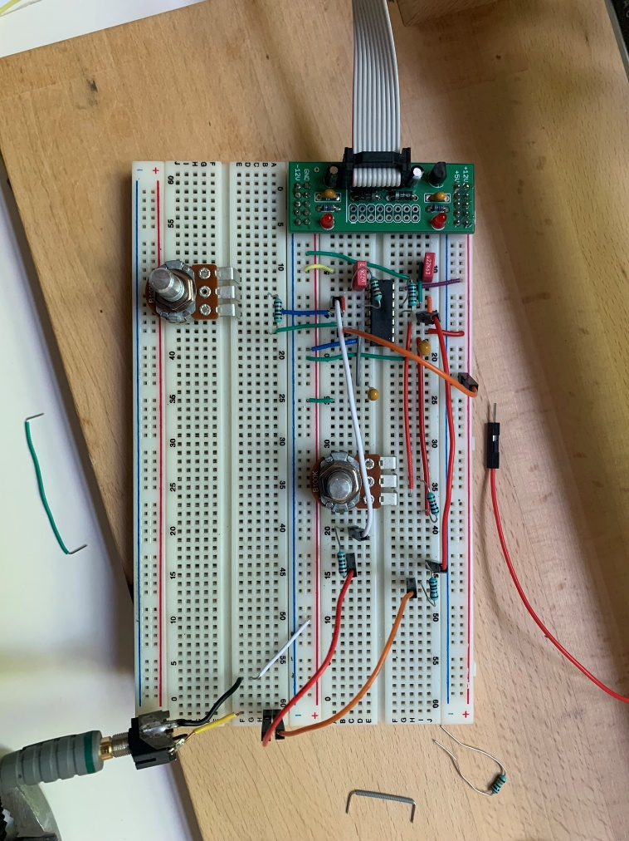

Appendix 6.11: Breadboard wiring of the first NAND oscillator design. Nikolaj Veljkovic [created 04 07 2024]

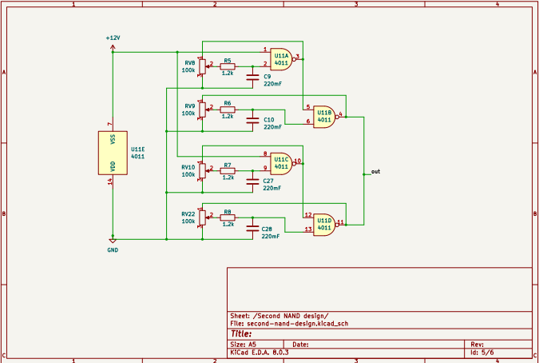

Appendix 6.12: Circuit diagram of the second NAND oscillator design. Nikolaj Veljkovic [created 15 10 2024]

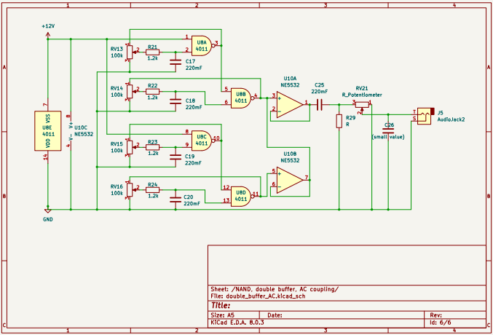

Appendix 6.13: Circuit diagram of the second NAND oscillator design with a two-stage buffer, AC coupling, and a low pass filter. Nikolaj Veljkovic [created 15 10 2024]

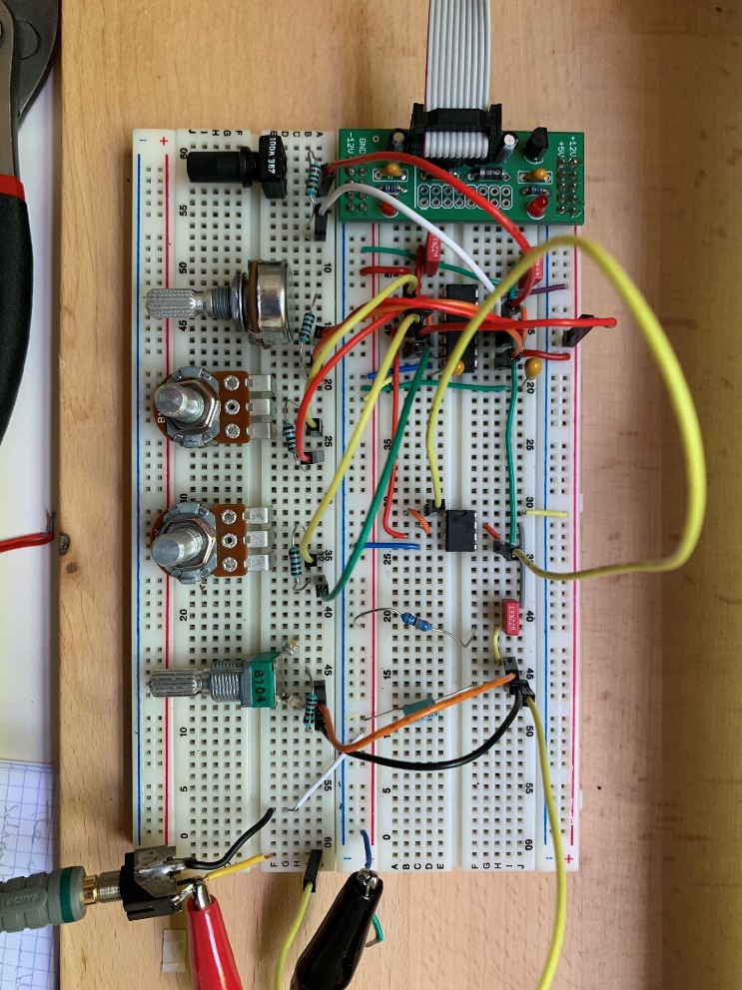

Appendix 6.14: Breadboard wiring of the above diagram. Nikolaj Veljkovic [created 04 07 2024]

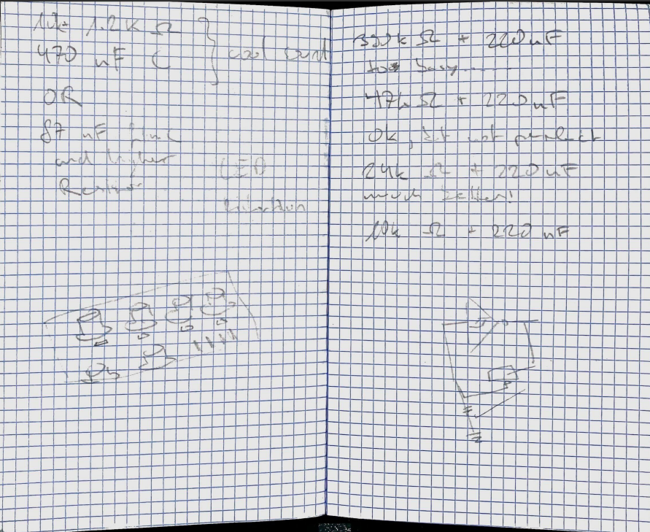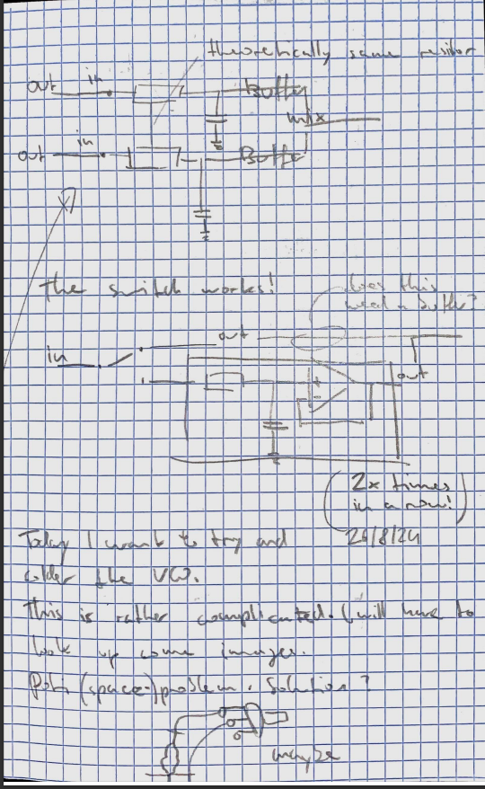

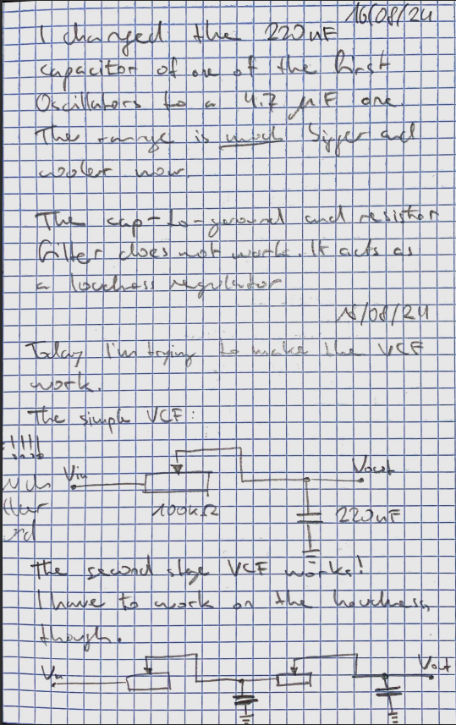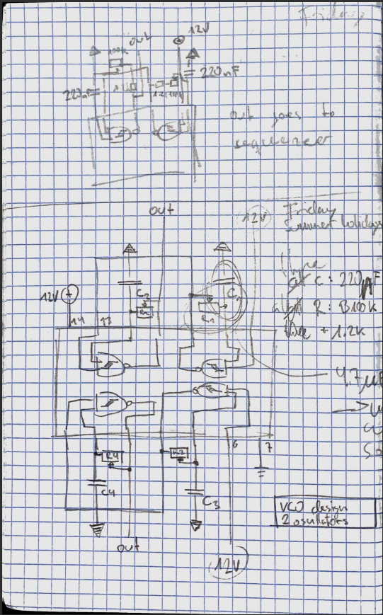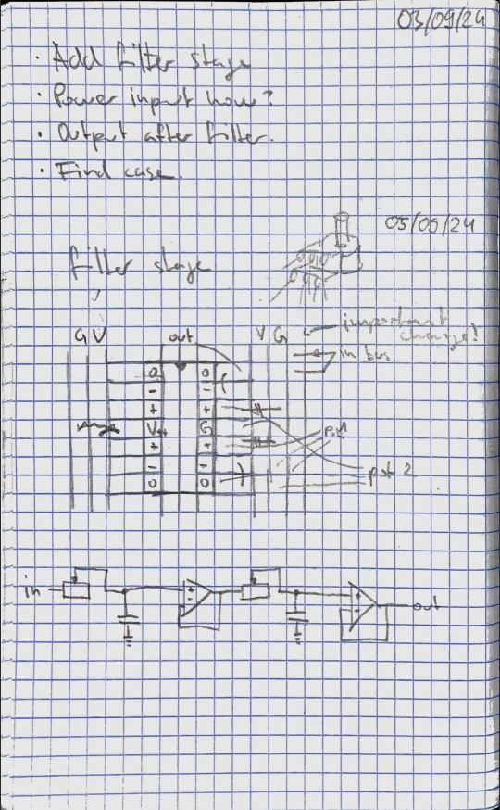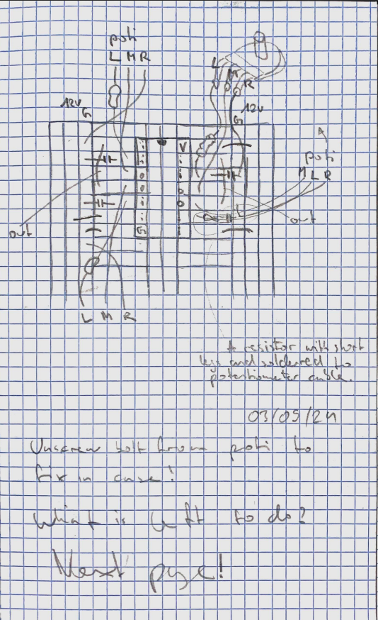

Appendix 6.15: Scans from my notebook. Nikolaj Veljkovic [08 2024 - 09 2024]

## References

|  |  |
| --- | --- |
| [1] | Ø. N. Dahl, “What is Ground in Electronic Circuits?,” buildelectroniccircuits, 18 09 2020. [Online]. Available: https://www.build-electronic-circuits.com/what-is-ground/. [Accessed 27 09 2024]. |
| [2] | B. Nussey, “Understanding the basics of electricity by thinking of it as water,” Freeing Energy, 02 11 2019. [Online]. Available: https://www.freeingenergy.com/understanding-the-basics-of-electricity-by-thinking-of-it-as-water/. [Accessed 11 10 2024]. |
| [3] | Hioki, “What is Resistance?,” Hioki, 2021. [Online]. Available: https://www.hioki.com/euro-en/learning/electricity/resistance.html. [Accessed 11 10 2024]. |
| [4] | EETech Group, “Resistor Materials,” EEPower, [Online]. Available: https://eepower.com/resistor-guide/resistor-materials/. [Accessed 24 06 2024]. |
| [5] | Ø. N. Dahl, “The Potentiometer: Pinout, Wiring, and How It Works,” buildelectroniccircuits, 11 08 2023. [Online]. Available: https://www.build-electronic-circuits.com/potentiometer/. [Accessed 11 10 2024]. |
| [6] | Britannica, “ohm,” Britannica, 30 08 2024. [Online]. Available: https://www.britannica.com/science/ohm. [Accessed 11 10 2024]. |
| [7] | M. Klein, “DIY SYNTH VCF Part 1: Analog Filtering Basics,” Moritz Klein on YouTube, 15 12 2020. [Online]. Available: https://www.youtube.com/watch?v=3tMGNI--ofU. [Accessed 03 07 2024]. |
| [8] | mackys, “The water-flow analogy for electronics, and how capacitors work.,” 19 07 2010. [Online]. Available: https://mackys.livejournal.com/914252.html. [Accessed 11 10 2024]. |
| [9] | University of Birmingham, “Physics A level revision resource: Introduction to capacitors,” University of Birmingham, 2024. [Online]. Available: https://www.birmingham.ac.uk/study/undergraduate/schools-and-colleges/post-16/a-level-stem-resources/capacitors. [Accessed 03 07 2024]. |
| [10] | P. Ravarini, “Farad,” Pravarini, 2024. [Online]. Available: http://pravarini.free.fr/Farad.htm. [Accessed 26 09 2024]. |
| [11] | R. Childers, “How to Read a Capacitor,” WikiHow, 3 10 2024. [Online]. Available: https://www.wikihow.com/Read-a-Capacitor. [Accessed 4 10 2024]. |
| [12] | Britannica, “integrated circuit,” Britannica, 24 06 2024. [Online]. Available: https://www.britannica.com/technology/integrated-circuit. [Accessed 26 09 2024]. |
| [13] | Texas Instruments, “LM741,” 10 2015. [Online]. Available: https://www.ti.com/lit/ds/symlink/lm741.pdf?ts=1728507715940. [Accessed 10 10 2024]. |
| [14] | Wikipedia, “Schmitt trigger,” Wikipedia, 21 09 2024. [Online]. Available: https://en.wikipedia.org/wiki/Schmitt_trigger. [Accessed 2024 09 25]. |
| [15] | Texas Instruments, “Understanding Schmitt Triggers,” 2022. [Online]. Available: https://www.ti.com/lit/ab/scea046a/scea046a.pdf?ts=1727485822924. [Accessed 10 10 2024]. |
| [16] | Tutoroot, “What are Analog and Digital Signals?,” Tutoroot, 01 05 2023. [Online]. Available: https://www.tutoroot.com/blog/what-are-analog-and-digital-signals-definition-difference-examples/. [Accessed 25 09 2024]. |
| [17] | StudySmarter, “Logic Circuits,” 2024. [Online]. Available: https://www.studysmarter.co.uk/explanations/computer-science/data-representation-in-computer-science/logic-circuits/. [Accessed 10 10 2024]. |
| [18] | Ø. N. Dahl, “AND Gate - Logic Gates Tutorial,” buildelectroniccircuits, 15 09 2022. [Online]. Available: https://www.build-electronic-circuits.com/and-gate/. [Accessed 12 10 2024]. |
| [19] | Ø. N. Dahl, “NOT Gate (Inverter) - Logic Gates Tutorial,” buildelectroniccircuits, 15 09 2022. [Online]. Available: https://www.build-electronic-circuits.com/not-gate/. [Accessed 12 10 2024]. |
| [20] | Ø. N. Dahl, “NAND Gate - Logic Gate Tutorial,” buildelectroniccircuits, 12 09 2022. [Online]. Available: https://www.build-electronic-circuits.com/nand-gate/. [Accessed 12 10 2024]. |
| [21] | Toshiba, “What is an op-amp?,” Toshiba, 2024. [Online]. Available: https://toshiba.semicon-storage.com/ap-en/semiconductor/knowledge/faq/linear_opamp/what-is-an-operational-amplifier.html. [Accessed 26 09 2024]. |
| [22] | Electronics Tutorials, “Operational Amplifier Basics,” Electronics Tutorials, 2024. [Online]. Available: https://www.electronics-tutorials.ws/opamp/opamp_1.html. [Accessed 12 10 2024]. |
| [23] | M. Klein, “DIY SYNTH VCF Part 2: Active Filters & Resonance,” Moritz Klein on YouTube, 04 01 2021. [Online]. Available: https://www.youtube.com/watch?v=YNoj9Rrw_VM. [Accessed 26 09 2024]. |
| [24] | M. Terrier and O. Novel, “Un buffer audio. (audio buffer),” Olga Novel & Michel Terrier, 28 07 2015. [Online]. Available: http://www.michelterrier.fr/radiocol/detail2003/buffer-audio.htm. [Accessed 11 10 2024]. |
| [25] | Inspirit, “Frequency And Pitch Of Sound Study Guide,” Inspirit, 28 03 2023. [Online]. Available: https://inspiritvr.com/frequency-and-pitch-of-sound-study-guide/. [Accessed 10 10 2024]. |
| [26] | L. Fisher, “Period of a Wave,” Study.com, 21 11 2023. [Online]. Available: https://study.com/learn/lesson/how-to-find-period-of-a-wave.html. [Accessed 12 10 2024]. |
| [27] | Britannica, “timbre,” Britannica, 03 09 2024. [Online]. Available: https://www.britannica.com/science/timbre. [Accessed 10 10 2024]. |
| [28] | N. Robehmed, “Sine, Square, Triangle, Saw - The Difference Between Waveforms and Why It Matters,” Perfect Circuit, 08 05 2019. [Online]. Available: https://www.perfectcircuit.com/signal/difference-between-waveforms. [Accessed 12 10 2024]. |
| [29] | L. Lanzilotti, “Harmonics, Waveforms, and the Overtone Series,” Leilehua Lanzilotti, 19 02 2016. [Online]. Available: http://leilehualanzilotti.com/blog/2016/2/11/on-harmonics-waveforms-the-overtone-series. [Accessed 10 10 2024]. |
| [30] | E. Corpeño, “Exactly How Schmitt Trigger Oscillators Work,” All About Circuits, 23 05 2018. [Online]. Available: https://www.allaboutcircuits.com/technical-articles/exactly-how-schmitt-trigger-oscillators-work/. [Accessed 28 09 2024]. |
| [31] | N. Collins, Handmade Electronic Music: The Art of Hardware Hacking, 2nd ed., Routledge, 2009. |
| [32] | R. E. Berg, “Overtones,” Britannica, 13 09 2024. [Online]. Available: https://www.britannica.com/science/sound-physics/Overtones#ref-14249. [Accessed 28 09 2024]. |
| [33] | Phermans, “Audio Synthesis of the Túngara Frog Call,” The Digital Naturalism Conference, 11 09 2019. [Online]. Available: https://www.dinacon.org/2019/09/11/laser-tungara-frog-synth/. [Accessed 12 10 2024]. |
| [34] | unacademy, “Coherent and Incoherent Addition of Waves,” unacademy, 2024. [Online]. Available: https://unacademy.com/content/cbse-class-11/study-material/physics/coherent-and-incoherent-addition-of-waves/. [Accessed 12 10 2024]. |
| [35] | S. Rise, “Voltage-Controlled Filter (VCF),” The Synthesizer Academy, [Online]. Available: https://synthesizeracademy.com/voltage-controlled-filter-vcf/. [Accessed 12 10 2024]. |
| [36] | Electronics Tutorial, “Passive Low Pass Filter,” Electronics Tutorial, 2024. [Online]. Available: https://www.electronics-tutorials.ws/filter/filter_2.html. [Accessed 12 10 2024]. |
| [37] | R. Keim, “What Is a Low Pass Filter? A Tutorial on the Basics of Passive RC Filters,” All About Circuits, 12 05 2019. [Online]. Available: https://www.allaboutcircuits.com/technical-articles/low-pass-filter-tutorial-basics-passive-RC-filter/. [Accessed 12 10 2024]. |
| [38] | Noise Engineering, “Getting Started: envelopes, VCAs, and attenuators,” Noise Engineering, [Online]. Available: https://noiseengineering.us/blogs/loquelic-literitas-the-blog/getting-started-envelopes-vcas-and-attenuators/. [Accessed 11 10 2024]. |
| [39] | Mackie, “What is a VCA?,” Mackie, [Online]. Available: https://mackie.com/en/blog/all/what_vca.html. [Accessed 10 10 2024]. |
| [40] | G. Reid, “An Introduction to VCAs,” Sound On Sound, 01 2000. [Online]. Available: https://www.soundonsound.com/techniques/introduction-vcas. [Accessed 10 10 2024]. |
| [41] | SoundBridge, “Voltage Controlled Amplifier (VCA) Explained,” SoundBridge, 13 12 2023. [Online]. Available: https://www.soundbridge.io/voltage-controlled-amplifier-explained. [Accessed 10 10 2024]. |
| [42] | 9xpad, “VCAs for Dummies (or is it just me?),” MODULARGrid, 31 07 2021. [Online]. Available: https://modulargrid.net/e/forum/posts/index/10288. [Accessed 10 10 2024]. |
| [43] | EARS2, “Envelope,” EARS2, [Online]. Available: https://ears2.eu/courses/manipulated-sounds/lessons/envelope. [Accessed 11 10 2024]. |
| [44] | M. Müller and T. Zunner, “Timbre,” AudioLabs Erlangen, 2015. [Online]. Available: https://www.audiolabs-erlangen.de/resources/MIR/FMP/C1/C1S3_Timbre.html. [Accessed 28 09 2024]. |
| [45] | Noise Engineering, “Getting Started: Gates vs. Triggers,” Noise Engineering, [Online]. Available: https://noiseengineering.us/blogs/loquelic-literitas-the-blog/getting-started-gates-vs-triggers/. [Accessed 11 10 2024]. |
| [46] | R. Hogben, “What is an envelope generator: ADSR envelopes and their role in sound design,” piqued, 04 05 2023. [Online]. Available: https://piqued.fm/what-is-an-envelope-generator-adsr-envelopes-and-their-role-in-sound-design/. [Accessed 11 10 2024]. |
| [47] | Native Instruments, “What is an LFO? How to use low frequency oscillators in music production,” Native Instruments, 17 07 2023. [Online]. Available: https://blog.native-instruments.com/what-is-an-lfo/. [Accessed 11 10 2024]. |
| [48] | BoZ, “J'apprends le synthétiseur : le LFO,” Synth Food, 19 03 2020. [Online]. Available: https://www.synthfood.fr/j-apprends-le-synthetiseur-le-lfo/#Cest-quoi-un-LFO. [Accessed 11 10 2024]. |
| [49] | 3D Varius, “History of the wah,” 3D Varius, 22 04 2022. [Online]. Available: https://www.3d-varius.com/history-of-the-wah/. [Accessed 28 09 2024]. |
| [50] | D. Solaris, “Synthesizer basics,” Don Solaris Sound Design, 18 03 2014. [Online]. Available: https://www.donsolaris.com/?p=493. [Accessed 29 09 2024]. |
| [51] | G. Weichhaus, Elektronik Basteln für Dummies, Wiley-Vch, 2020. |
| [52] | M-Short and Joel_E_B, “How to Use a Breadboard,” Sparkfun, [Online]. Available: https://learn.sparkfun.com/tutorials/how-to-use-a-breadboard/all. [Accessed 12 10 2024]. |
| [53] | Sweetwater, “Summing Resistor,” Sweetwater, 16 08 2004. [Online]. Available: https://www.sweetwater.com/insync/summing-resistor/. [Accessed 12 10 2024]. |
| [54] | E. Tutorials, “The Summing Amplifier,” Electronics Tutorials, 2024. [Online]. Available: https://www.electronics-tutorials.ws/opamp/opamp_4.html. [Accessed 12 10 2024]. |
| [55] | E. Tutorial, “Second Order Filters,” Electronics Tutorial, 2024. [Online]. Available: https://www.electronics-tutorials.ws/filter/second-order-filters.html. [Accessed 12 10 2024]. |
| [56] | Kate, “Guid to stripboard: a board for circuit connection and test,” IBE Electronics, 06 06 2023. [Online]. Available: https://www.pcbaaa.com/guide-to-stripboard-a-board-for-circuit-connection-and-test/. [Accessed 14 10 2024]. |
| [57] | ICSocketSolutions.com, “IC Socket Technical Information,” Enplas Semiconductor Peripheral Company, 18 05 2021. [Online]. Available: https://ic-socket-solutions.com/en/blog/468/. [Accessed 14 10 2024]. |
| [58] | GreatOldOneK2LU, “What is this small metal piece ...,” Reddit r/Luthier, 2023. [Online]. Available: https://www.reddit.com/r/Luthier/comments/12zzboe/what_is_this_small_metal_piece_sticking_up_on_the/. [Accessed 14 10 2024]. |

# Statutory declaration

Hereby I confirm that I have written the present matura paper by myself and in the process have used no other than the mentioned sources. The literal or contextual copying of content has been marked as such by the according citations. When translating certain words I used Google Translate.

Nikolaj Veljkovic

Bern, 18. Oktober 2024

Signature:

